Pierce, Austin D

Pellissippi State Community College

CITC-2320 PC7 HOHOHO Company Infrastructure Documentation

GitHub link: <https://github.com/LeatherBandit/ServerFinal>

Contents

Windows Server 2019 Installation 2

Initial Server Configuration Tasks 6

Promotion to Domain Controller. 26

Create additional drives 31

Create Web Server via IIS 37

Group Policy Settings 41

Create Users and Groups 45

AD OU Structure 50

Create Folders, Directories and Shares 52

Special User Permissions 64

Active Hours 64

Printers 65

Windows Client 70

IP TABLE: 76

## Windows Server 2019 Installation

1. **Create a new virtual machine in VMware workstation.** 
   1. Select “Create a New Virtual Machine” in VMware workstation.
   2. Select “Custom (advanced)” for installation.  
      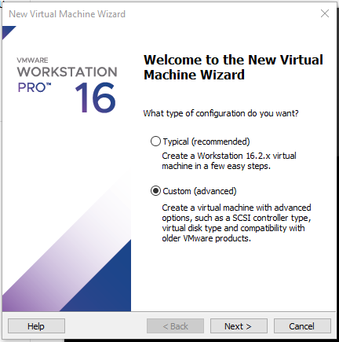
   3. Ensure “Workstation 16.2.x” is selected next to Hardware.  
      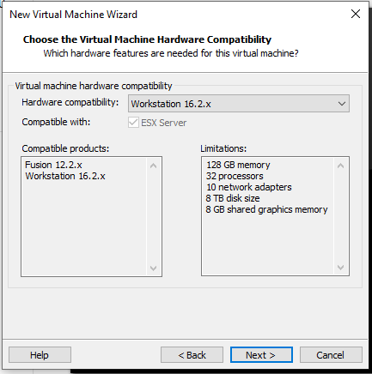
   4. Select “I will install the operating system later”  
      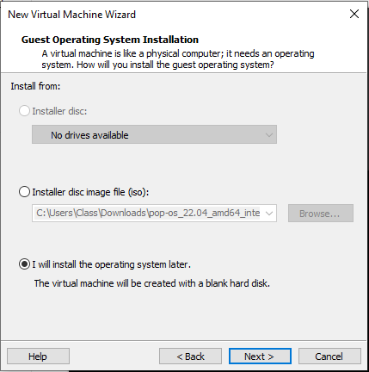
   5. Click the “Other” radio button. Select other on the version drop-down as well.  
      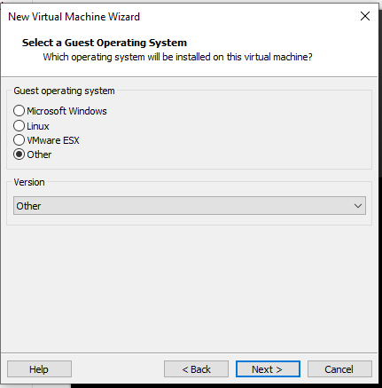
   6. Name it per company standard. “HHH-04 Windows Server 2019”
   7. Number of processors “2”, Number of cores per processor “4”.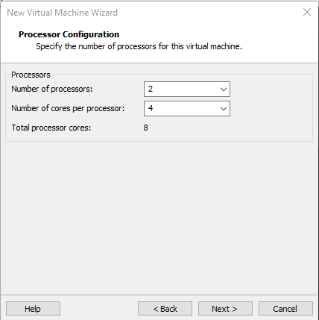
   8. Input “4096” MB for ram allocation.  
      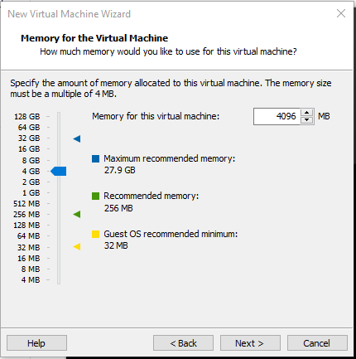
   9. Use default of “NAT” for the Network Type.
   10. Use default of “LSI Logic SAS”.
   11. Use default of “NVMe” or your recommended default.
   12. Use default of “create a new virtual disk”
   13. Input at least “50GB” for the drive capacity.  
       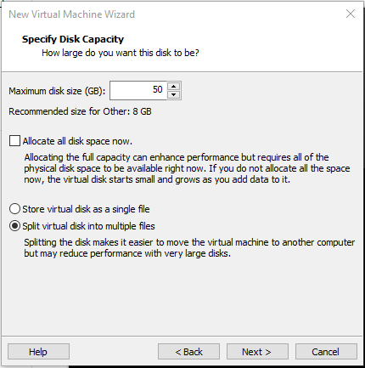
   14. Use default name for the disk file.
   15. Review and finish.  
       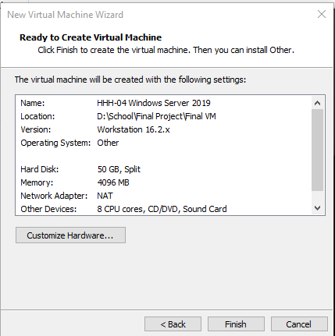
   16. On the Home screen: Select your new virtual machine’s CD/DVD item.
   17. Under connection: Select “use ISO image file”.
   18. Browse for your downloaded copy of “Windows Server 2016 Eval Edition” and select it  
       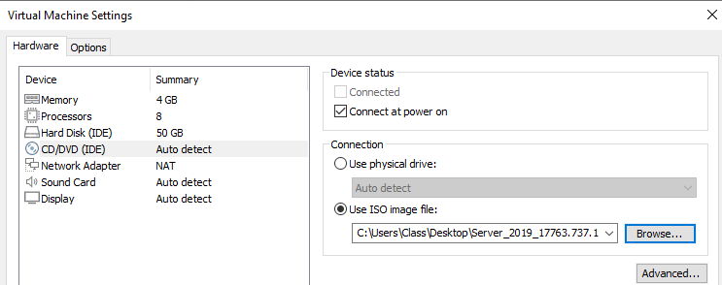

## Initial Server Configuration Tasks

1. **Complete initial windows setup tasks as guided by the operating system.**
2. **Be sure to install Guest additions CD per VMware instructions.** 
   1. This can be done manually via the VMware tools .iso file. Click VM in top of VMware workstation client and select “Install Guest additions”.
   2. Select “Install VMware Tools”
   3. Press “WinKey + R” and type “D:\setup.exe”. This will start the tool installation.
   4. Select the installation manager from the task bar.
   5. Follow steps in the installation manager to complete the VMware tools installation.
   6. If this completes properly, your virtual machine should resize to fit the full display.
   7. Restart after the installation is complete.
   8. After restart sign in again.
3. Change password policy to allow for 2-character password. (Not recommended for production environments.)
   1. Open “Local Group Policy Editor” through the windows search feature.  
      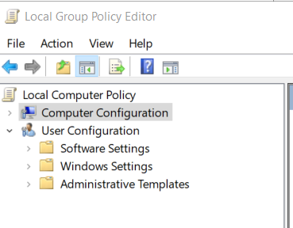
   2. Break out the tree until you’ve found “Password Policy” – (Computer Configuration > Windows Settings > Security Settings > Password Policy)  
      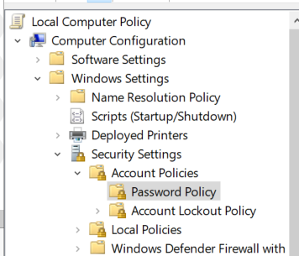
   3. Select “Minimum password length” and change the value to “0” characters. Apply changes.  
      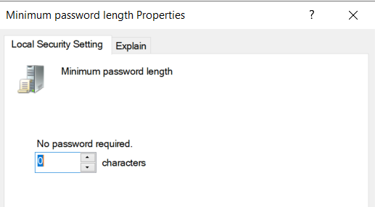
   4. Select “Password must meet complexity requirements Properties” and disable this option. Apply changes.  
      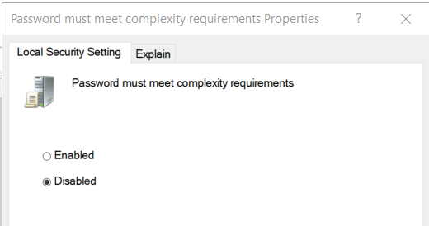
   5. Change the Administrator password to pw. Press “Win Key + R” and type lusrmgr.msc. Hit enter.  
      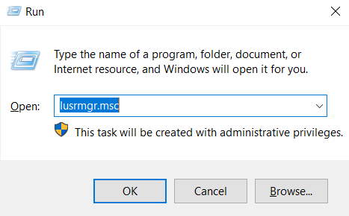
   6. Double click the “User” tree.  
      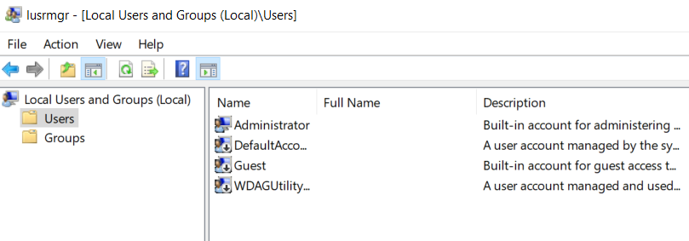
   7. Right click “Administrator” and select “Set Password”. On the next prompt click “Proceed”.  
      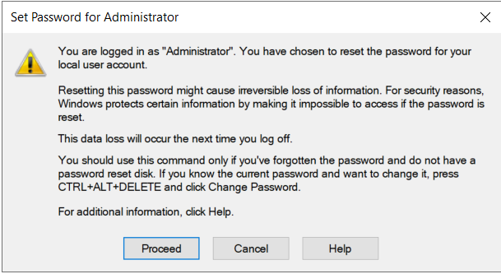
   8. Set password as “pw” and select “ok”  
      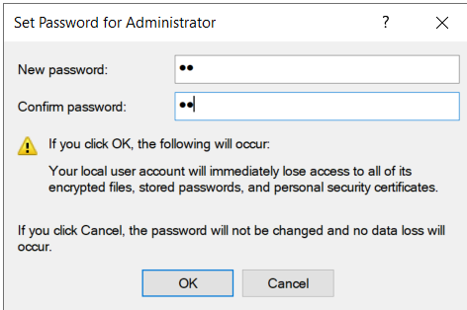
4. Create Admin account to avoid using “Administrator”
   1. With “lusrmgr.msc” still open, right click in the center section, and select “New User”.  
      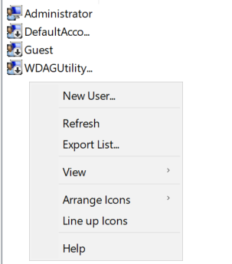
   2. Fill out the basic information for our “HOADM” local admin account as follows:  
      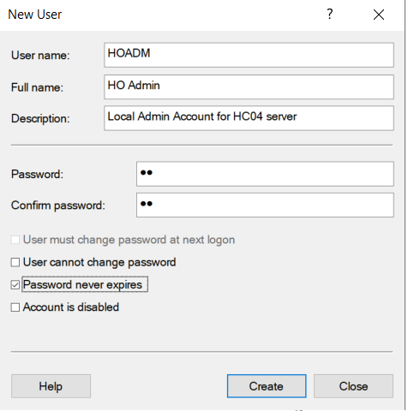
   3. Select “Create” to finalize, and verify the user has been created in the view pane.  
      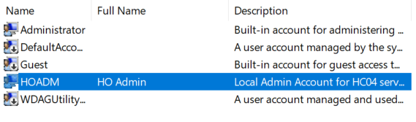
   4. Right click the new user and select properties. Navigate to “Member Of” tab.  
      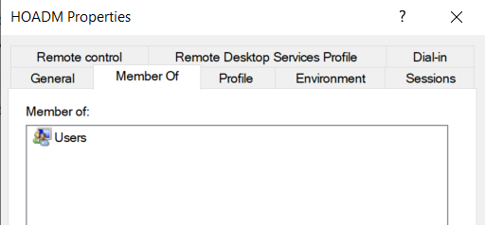
   5. Select “Add” and type in “Administrators” into the text box, hit enter.  
      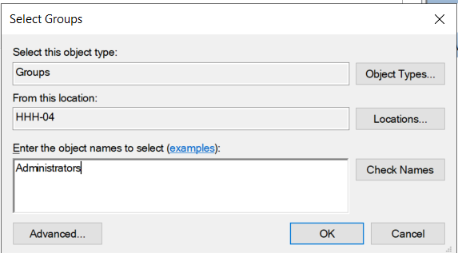
   6. Apply changes and switch users to the new admin account.  
      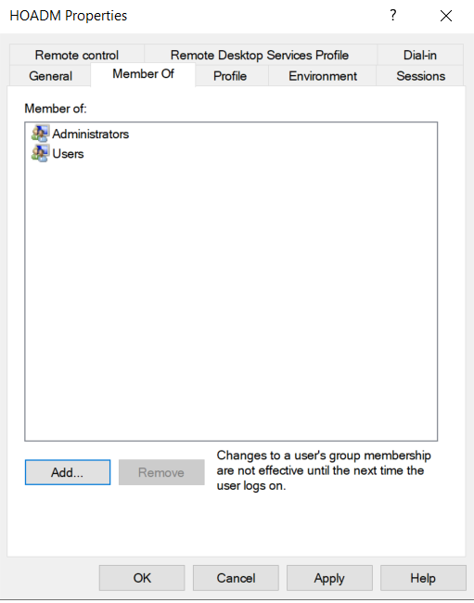
   7. Login to the “HO Admin” account.  
      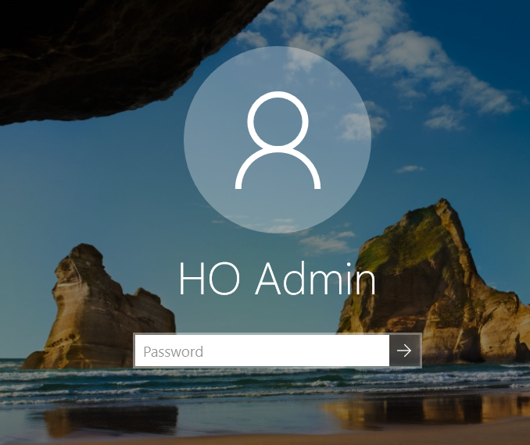
   8. Open cmd by searching in windows. Enter “whoami” into the command line. This will verify your signed in user.  
      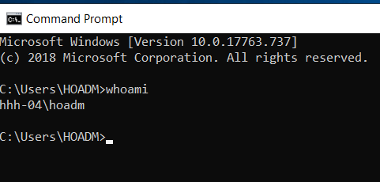
5. **Set the time zone.**
   1. From “Server Manager” select “Local Server”  
      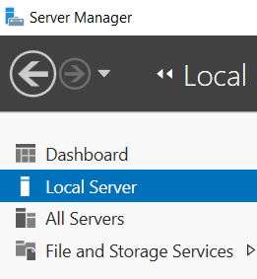
   2. Select “Time Zone”  
      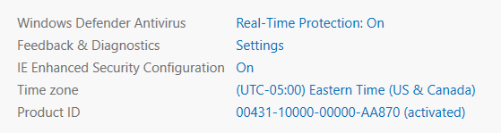
   3. Select “Change time zone”  
      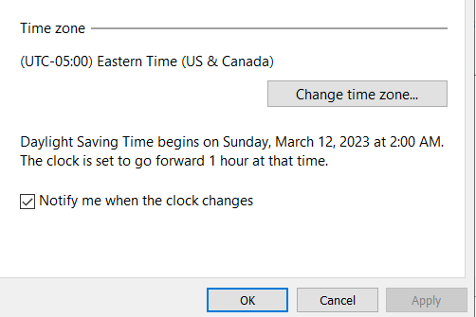
   4. Set proper time zone and apply changes with the “OK” button.
6. **Set machine name and workgroup:**
   1. From the same “Local Server” tab select “Computer name”.  
      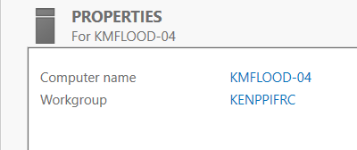
   2. Set an appropriate description for this server.  
      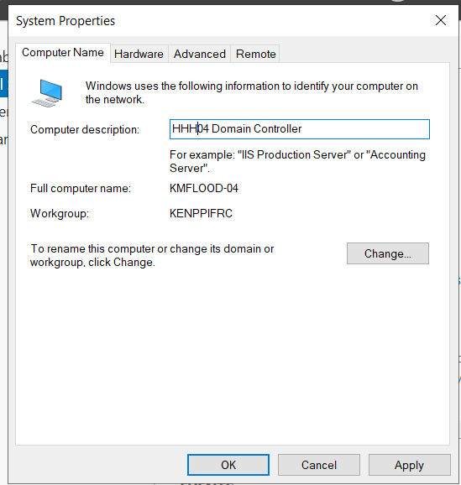
   3. Select Change to modify the name and workgroup. Note the workgroup does not need to be changed since this will be promoted to a domain controller but for the sake of clarity go ahead and set it appropriately.  
      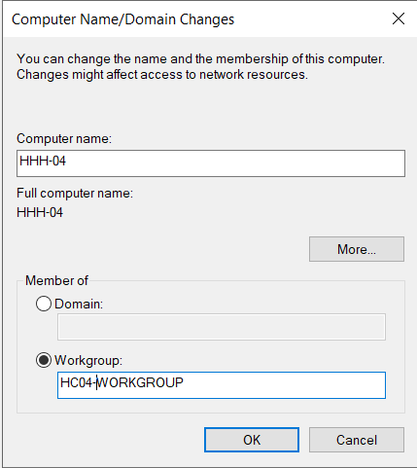
   4. Apply Changes and restart machine when prompted.   
      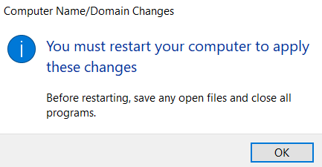
7. **Collect Logs from event viewer:**
   1. Open event view by searching for “event viewer” in the windows search tool.  
      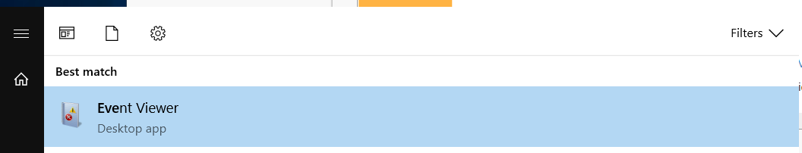
   2. In the forest on the left side of the screen click the drop-down arrow for “Windows Logs”.  
      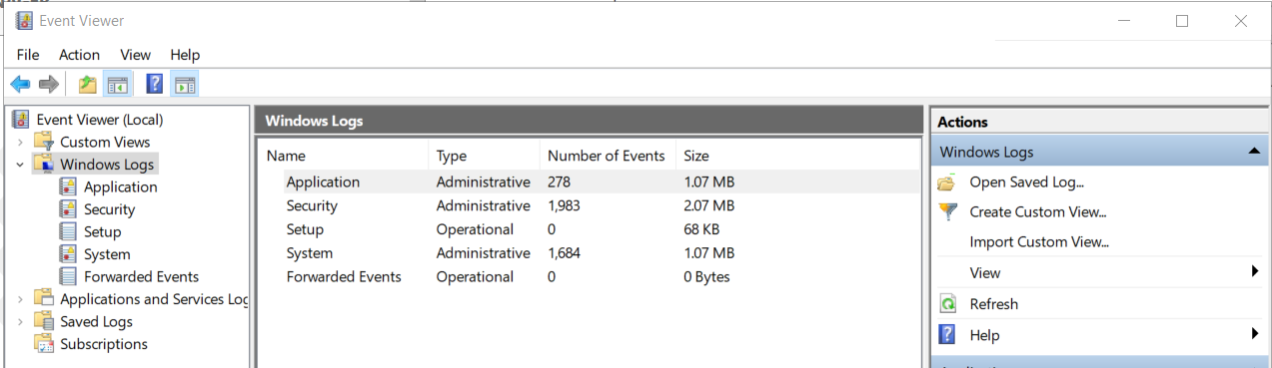
   3. For each log section “Application, Security, System” repeat steps “d – e”.
   4. Select the log section “Application for example”. Select “clear log…”  
      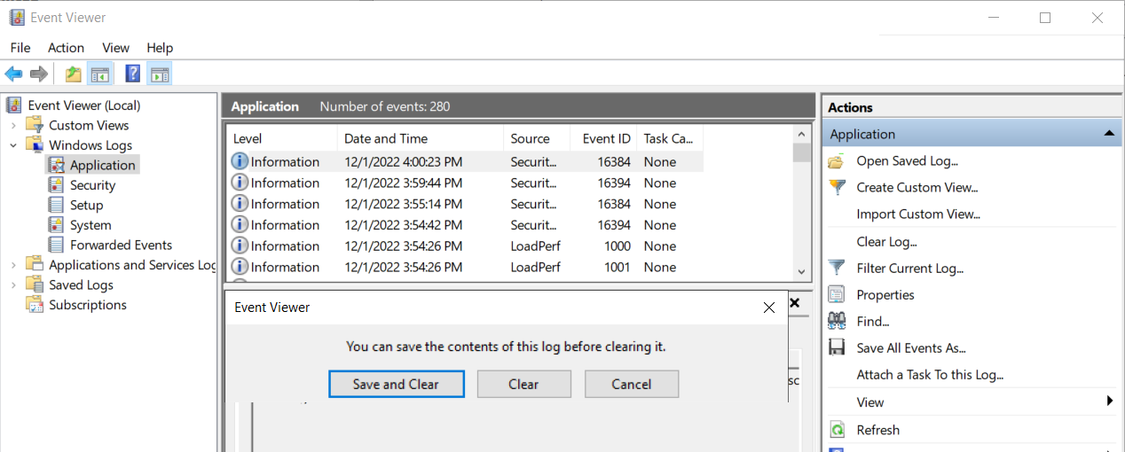
   5. In the pop-up window select the option “Save and Clear”. Save the files in “Documents” as “APP-LOG-FULL-2022-DEC-01-406” (Section-LOG-FULL-MONTH-DAY-HOUR).  
      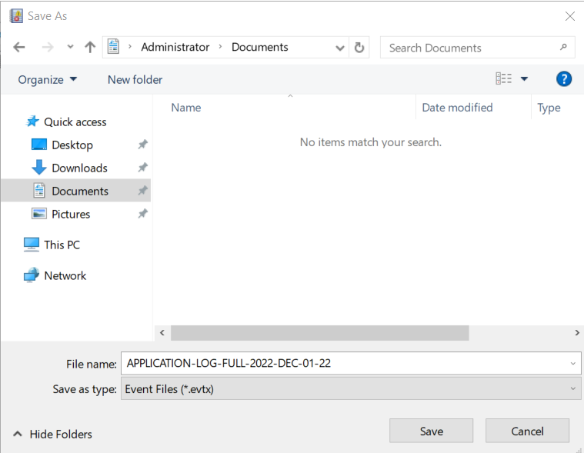
8. Set Static IP Address:
   1. Open CMD by searching “CMD” in windows. Type “ipconfig” in the command line.  
      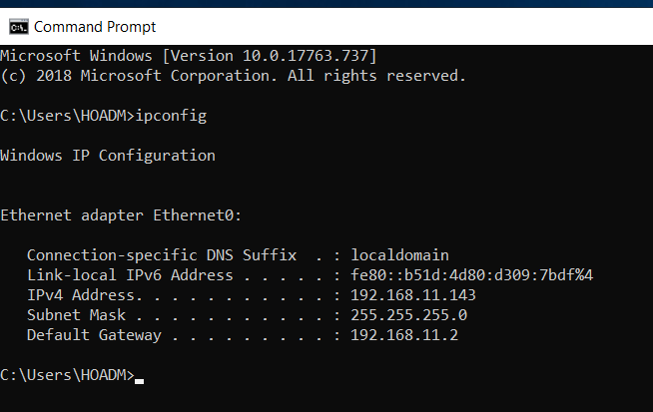
   2. Under “IPv4 Address” document the information listed. In the command line type “ncpa.cpl” to open network adapter properties.  
      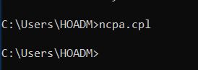
   3. On the “Network Connections” right click Eth0 and select properties.   
      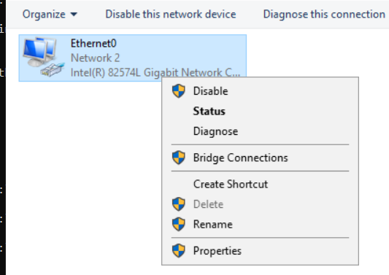
   4. Select “Internet Protocol Version 4 (TCP/IPv4)” and click properties.  
      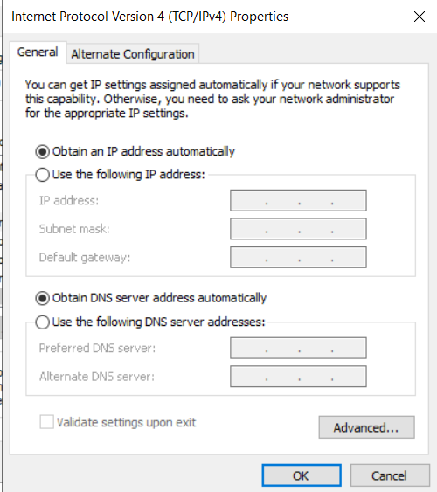
   5. Click “Use the following IP address” fill in the information from our previous documentation  
      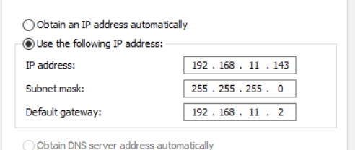
   6. The DNS settings will be the same as your default gateway. You can set the secondary to Google DNS for redundancy.   
      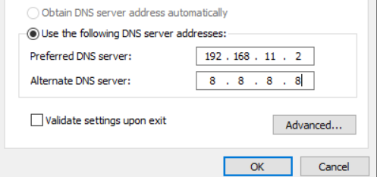
   7. Save and close. Back in the command line run “ipconfig /all”. Verify DHCP enabled is listed as “No”  
      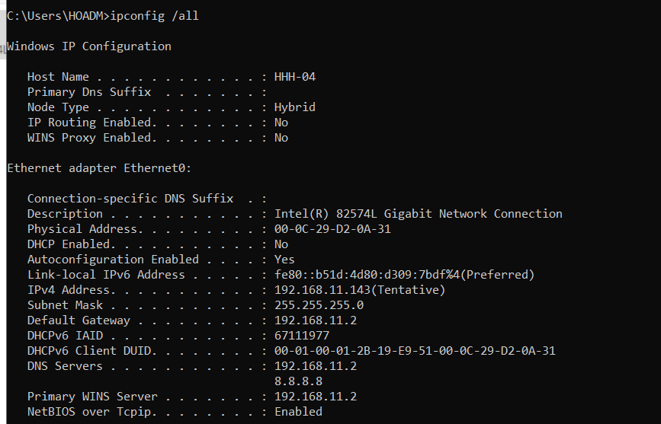
9. Configure Power Scheme:
   1. Search for “Power” in windows search.   
      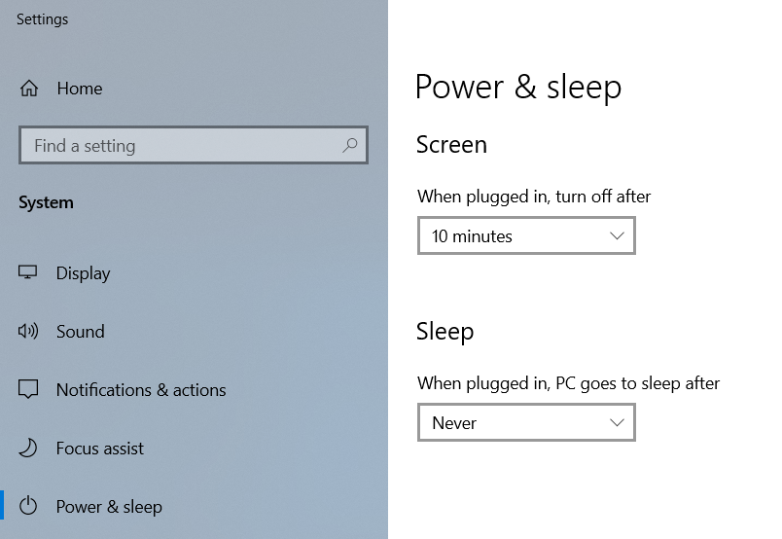
   2. Select “Additional Power Settings.  
      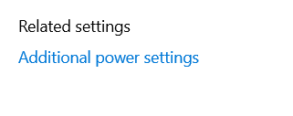
   3. Select “Create a power plan”  
      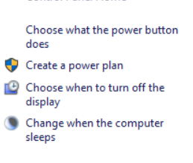
   4. Name Power Plan appropriately.  
      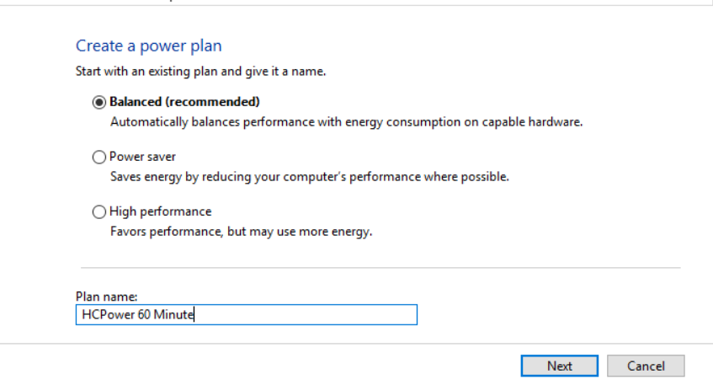
   5. Configure display timeout for 60 minutes, and sleep to never. Create to finalize.   
      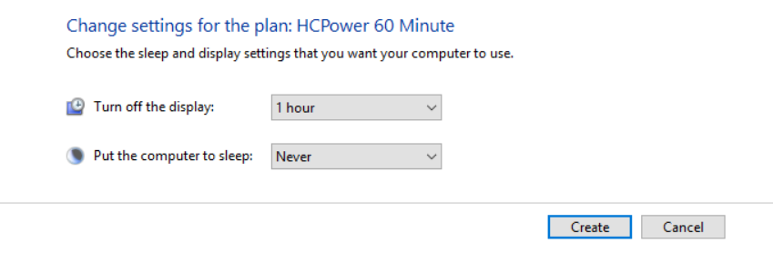
10. Defragment C drive.
    1. In windows search type “Defragment”.   
       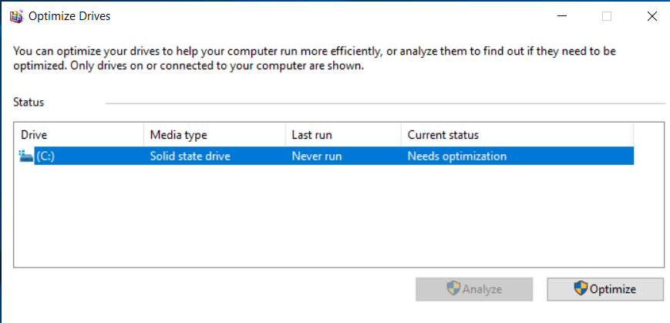
    2. Select “Optimize” to “Defragment or trim” depending on the type of drive.  
       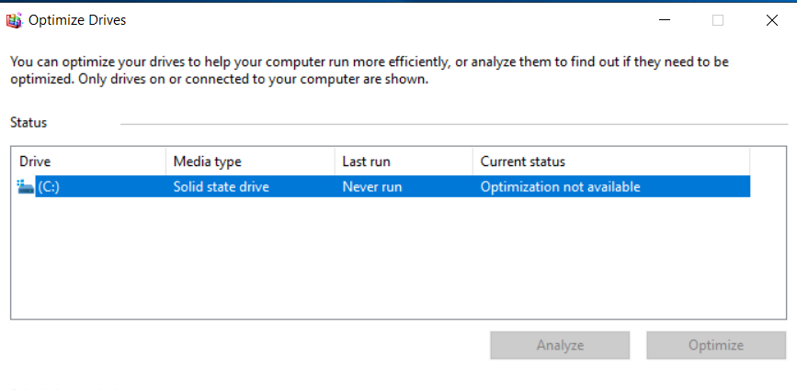
    3. Shut the machine down to perform the defragmentation from the VMware side as well. Select “Edit virtual machine settings”, and select your Hard disk.   
       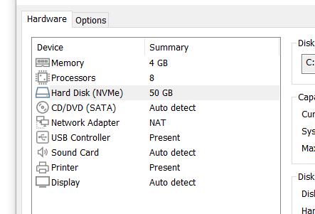
    4. Select the “defragment” option.   
       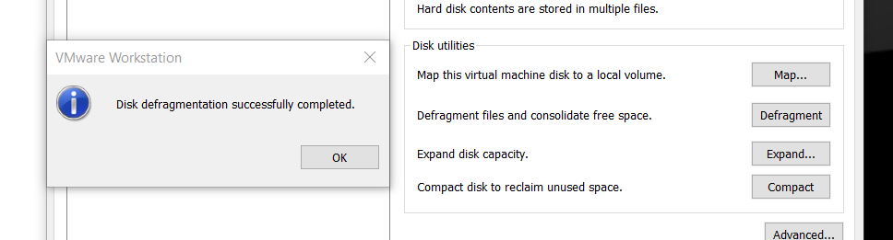
11. Custom Keyboard Settings:
    1. Search for “Edit Language and keyboard options”  
       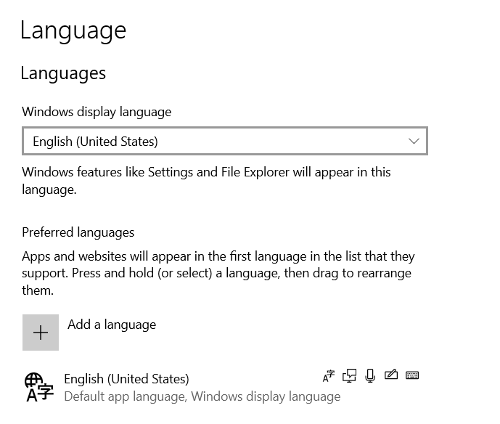
    2. Add a language. Select the most appropriate language for your employees. Spanish in this case.   
       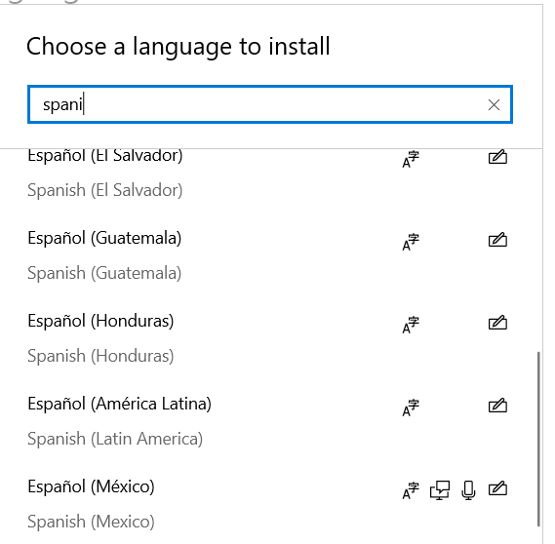
    3. Install the language features required. Speech and handwriting are not required in this case.   
       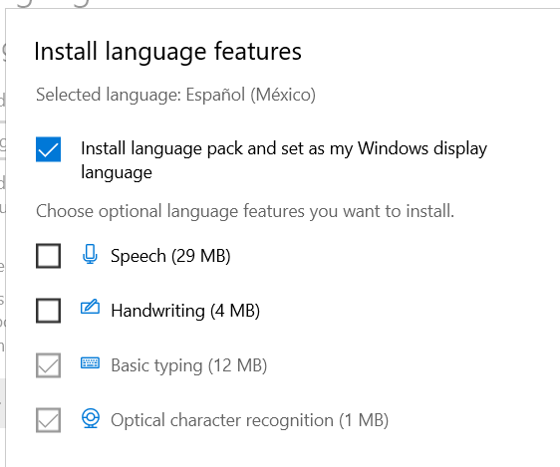
    4. Complete the language installation and order as necessary.   
       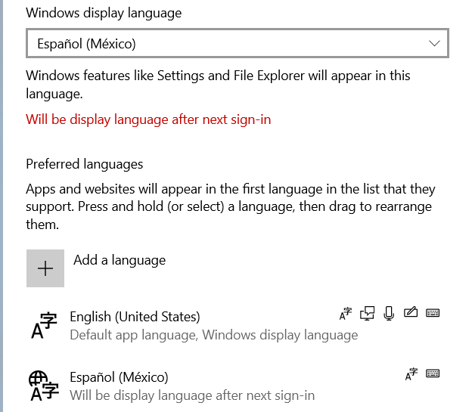
12. Configure NO memory dump.
    1. Open control panel by searching for “control panel” in the windows search tool. Navigate to “System and Security” > “System” > “Advanced System Settings"  
       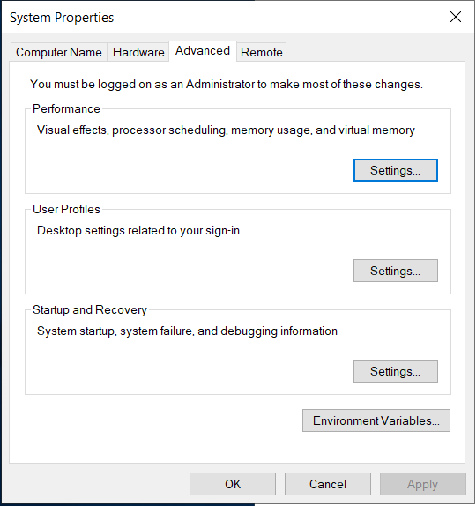
    2. Select “Settings” for startup and recovery.  
       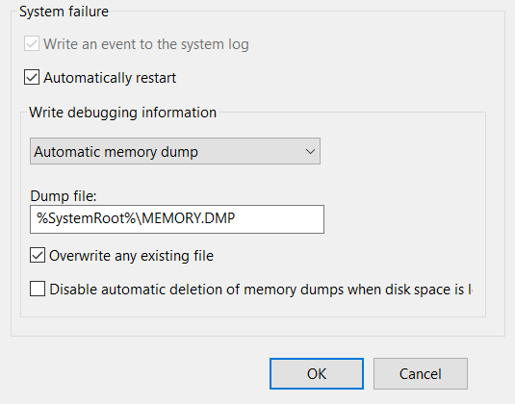
    3. Change automatic memory dump to “none” from the drop-down menu.  
       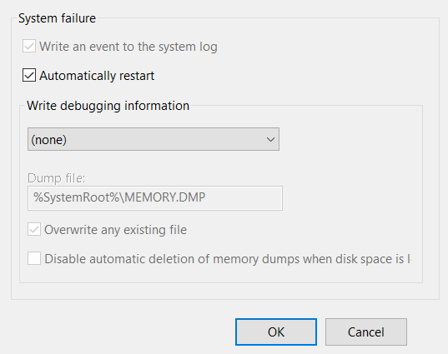

## Promotion to Domain Controller.

1. Snapshot before promotion.
   1. Out of an abundance of caution we will save our progress by creating a snapshot of the machine’s state.
   2. In the VMware menu, select VM > Snapshot > Take snapshot.  
      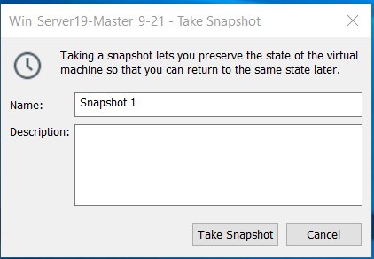
   3. Create a descriptive title and clear description. Select Take Snapshot. In the VM tab once again, select Snapshot > Snapshot Manager.  
      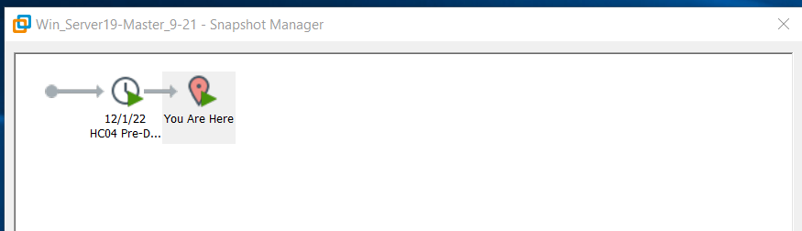
   4. Select the snapshot we just created to verify successful creation.  
      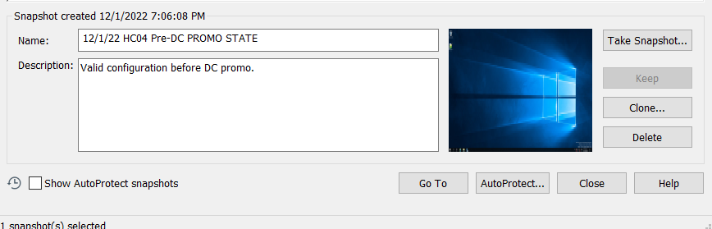
2. Capture logs before DC promotion.
   1. Repeat Event log capture workflow as detailed in Step 7. Of the initial configuration guide.
   2. Create “HOHOHO LOGS” folder and capture logs for users and groups.
      1. In a command prompt type the following command.   
         “mkdir "%USERPROFILE%\Documents\HOHOHO LOGS"   
         
      2. Followed by:  
         cd "%USERPROFILE%\Documents\HOHOHO LOGS"  
         
      3. Next we will capture local users followed by verifying the file was successfully created.  
         net user > HOHOHO-USRS1-B4DC.txt  
         type HOHOHO-USRS1-B4DC.txt  
         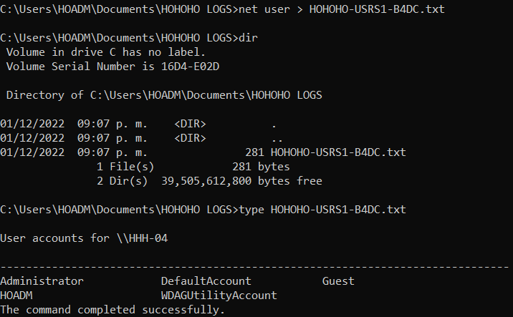
      4. We will do the same process for groups.   
         net localgroup > HOHOHO-GRPS1-B4DC.txt  
         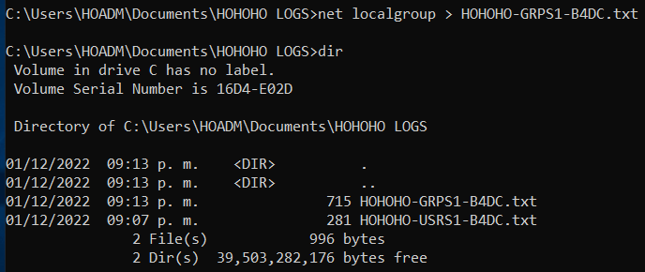
3. Promote server to Domain Controller.
   1. In the “Server Manager” under local server. Select “Manage” in the top right. Select “Add roles and Features”.  
      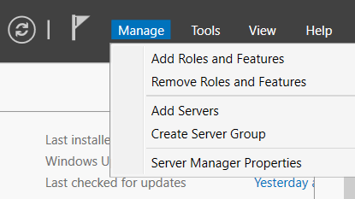
   2. Use the default settings until the “Select Server Roles” page. Select “Active Directory Domain Services”. Select “Add Features”  
      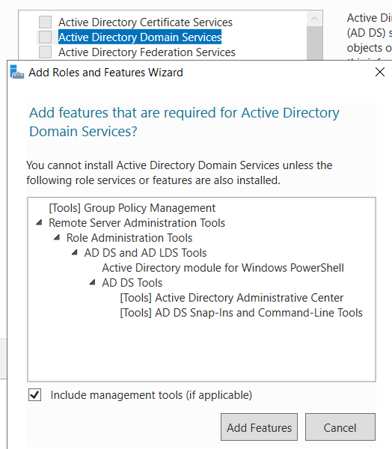
   3. Click next on each the next prompts until the “Confirm Installation Selections”. Restart the server automatically. Finish the installation.  
      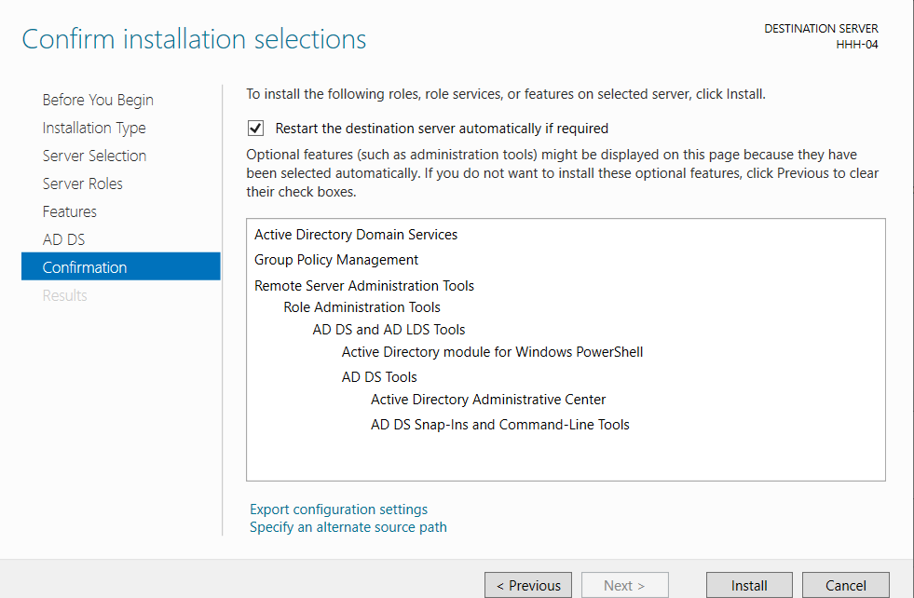
   4. Back on the server manager, click the notification icon in the upper right-hand corner. Select “Promote this server to a domain controller”.  
      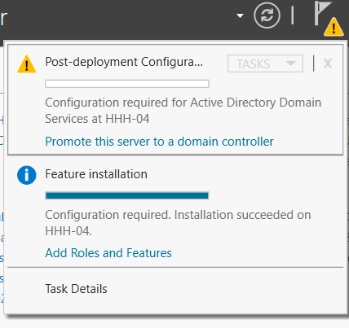
   5. Select “Add a new forest” and add the Domain name.  
      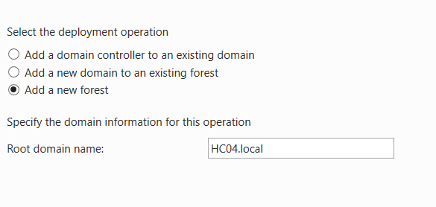
   6. Create a secure password for the “DSRM” as it can be used to restore your domain.  
      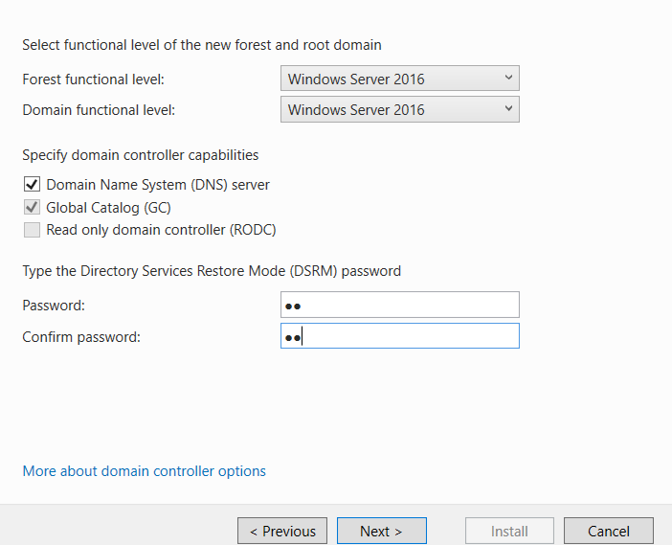
   7. Leave defaults until the Prerequisites Check page. Verify your settings and install.  
      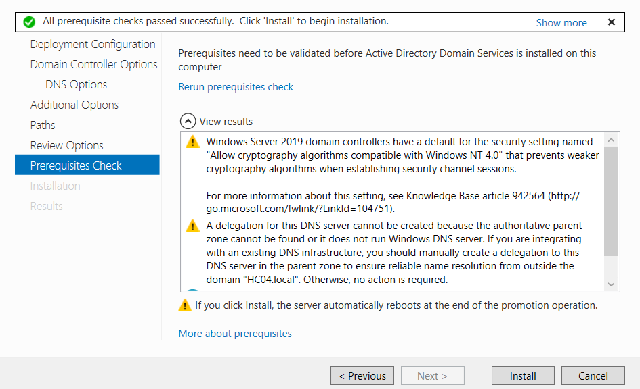
   8. Reboot:  
      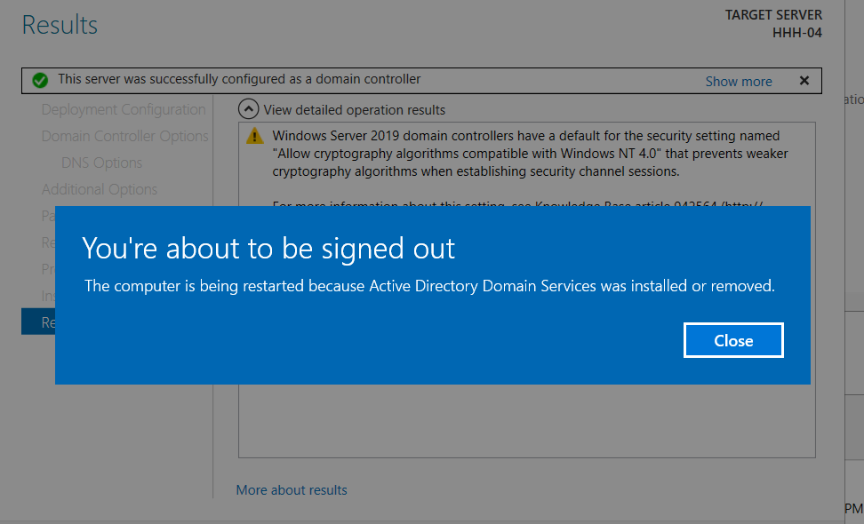

## Create additional drives

1. In VMware, click the “VM” tab. Select settings.   
   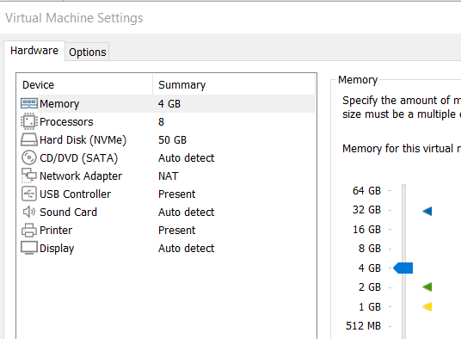
2. Select Add. Add Hard Disk. Leave the default disk type.  
   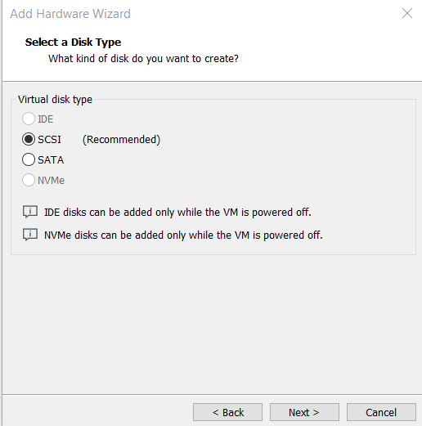
3. Create a “new virtual disk”. Select the appropriate size. 2GB in this case. Leave the default value of split into multiple files.   
   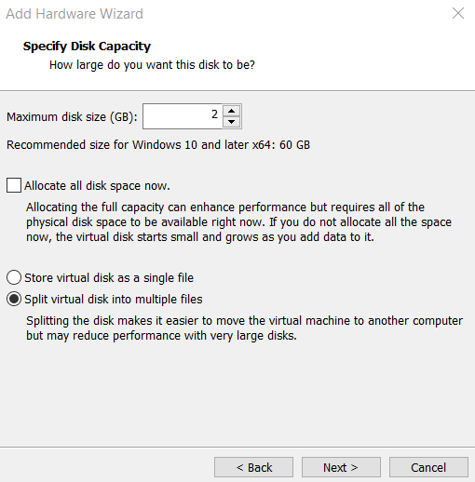
4. Leave disk file as default.  
   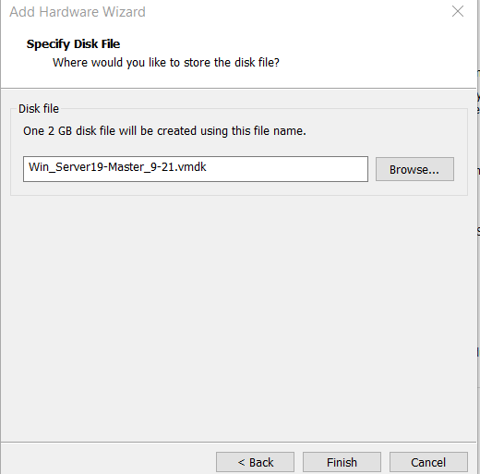
5. Repeat steps 2-4 for the following devices.
   1. F Drive: 2GB
   2. H Drive: 3GB
   3. N Drive: 1GB
   4. S Drive: 2GB
   5. P Drive: 2GB  
      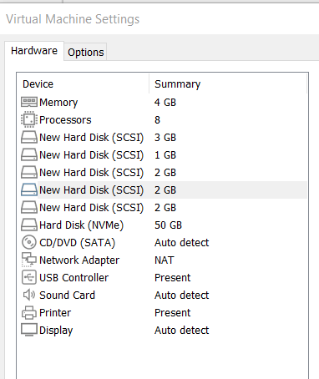
6. We need to now initialize each in windows.
   1. Search disk management in windows search.  
      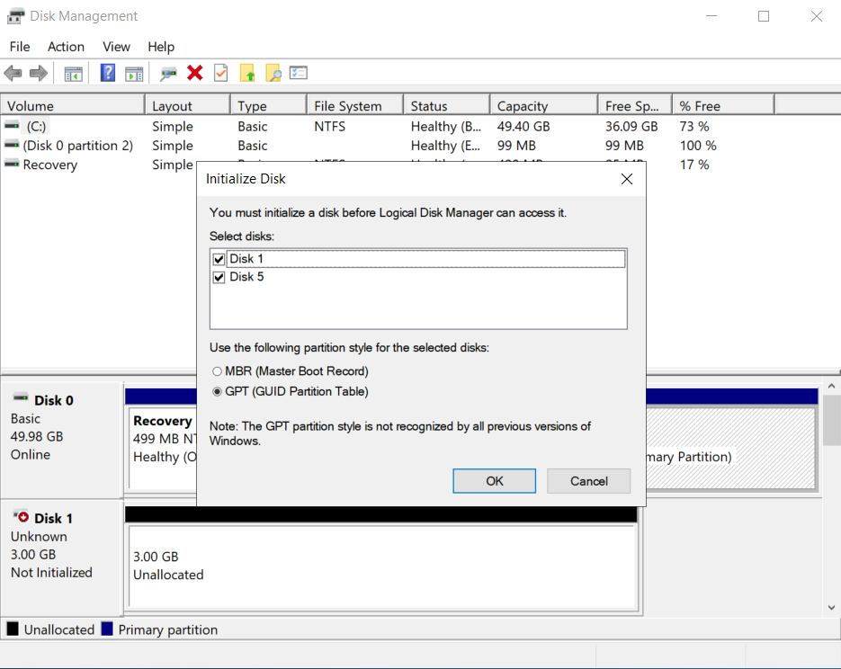
   2. For the pop-up window we can select GPT and both disks, and select ok.  
      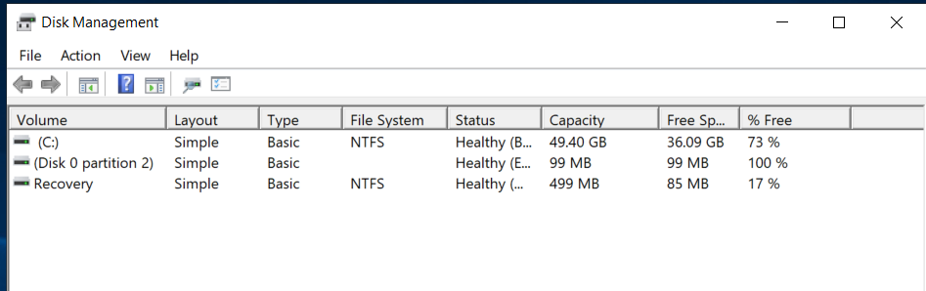
   3. We need to ensure each disk is online by right clicking the “Disk x” box and selecting “online”.  
      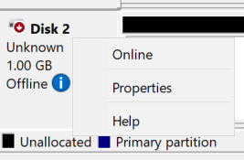
   4. We will also need to initialize each disk with the GPT partition style.  
      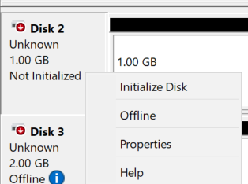
   5. For each disk we will need to create simple volumes that encompass the entire available space for each. Select the unallocated space and start a “new simple volume”  
      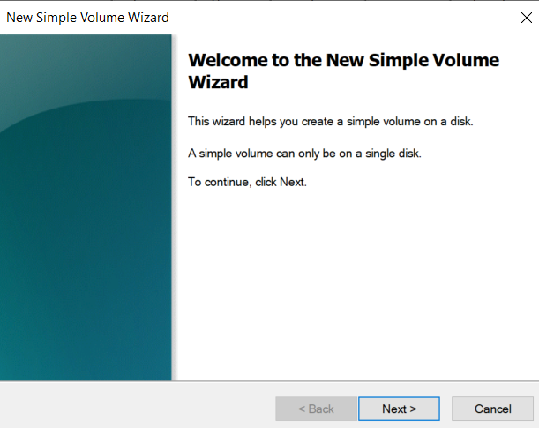
   6. Leave defaults for each prompt until the Drive letter assignment. Ensure you assign the correct drive letter for each volume.  
      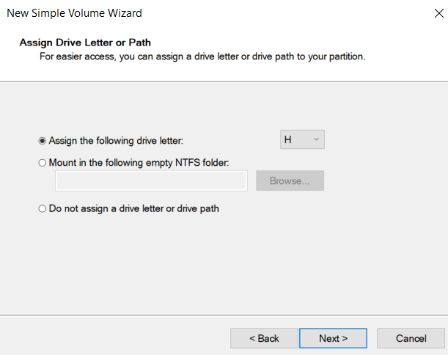
   7. Next we will leave the defaults for File system type as it is already NTFS. Label volume appropriately.   
      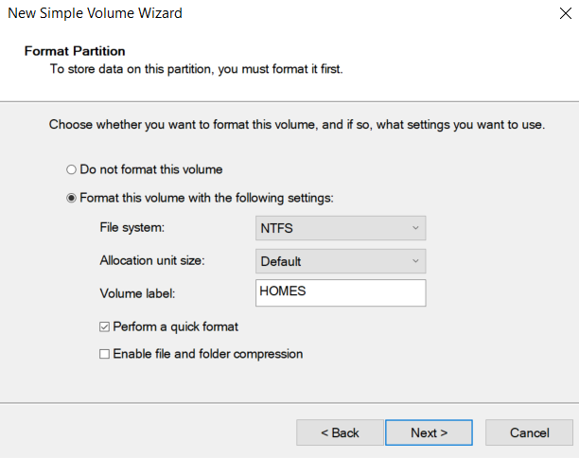
   8. Finalize settings. And repeat for each drive.  
      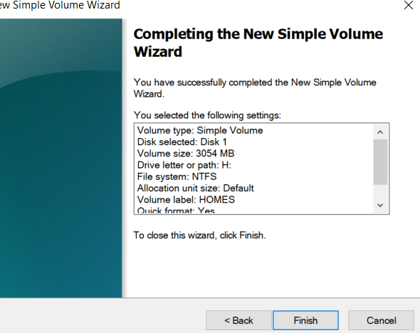
   9. Review disks.   
      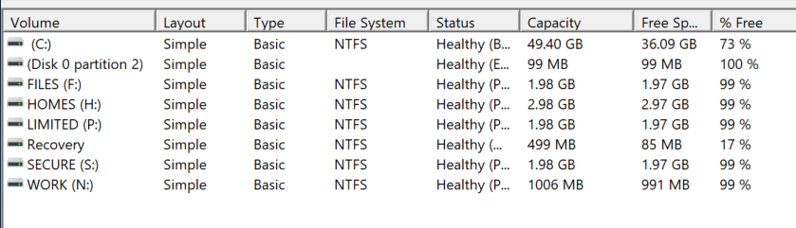

## Create Web Server via IIS

1. In server manager, click “manage” in the top right. Select Add roles and features.  
   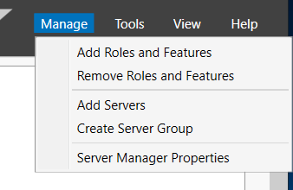
2. Leave all defaults until you get to the “Select Server Roles”. On this page select “Web Server IIS”. Add features as directed.   
   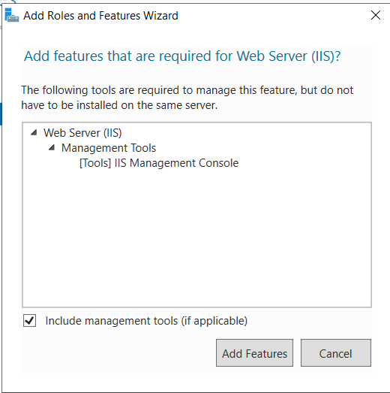
3. Leave all defaults until the “Role Services” section. Here you can optionally enable “logging tools”.  
   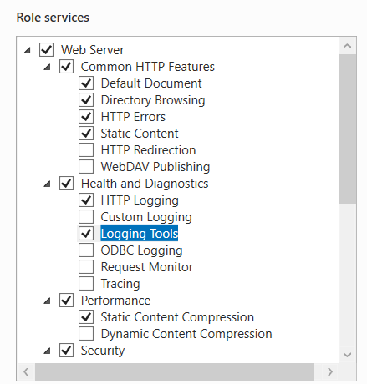
4. Complete Installation.  
   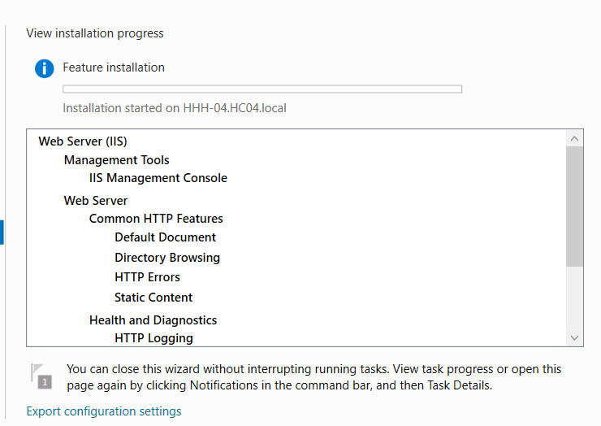
5. Verify installation by click in the notification tab in server manager.   
   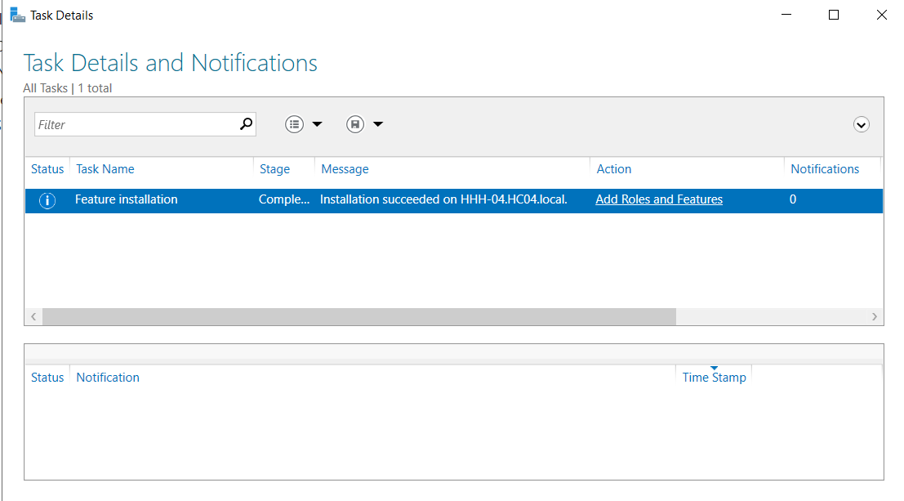
6. We now need to modify our HTML document to include our custom information. We need to navigate to “C:\inetpub\wwwroot”.  
   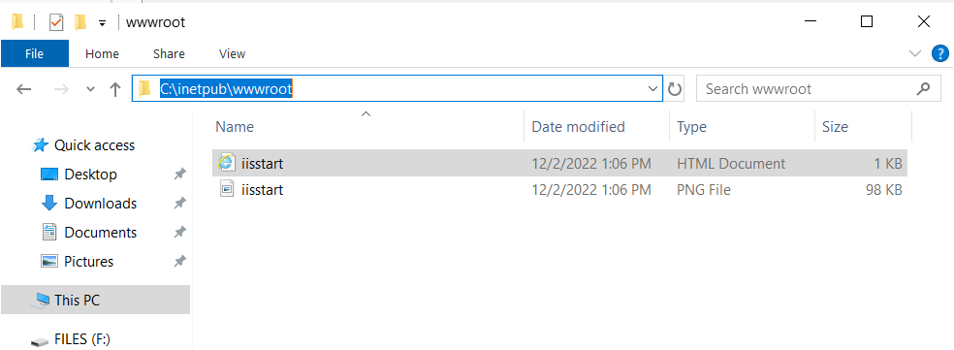
7. To quickly modify this information, we can simply right-click on “iisstart” and edit in a text editor.   
   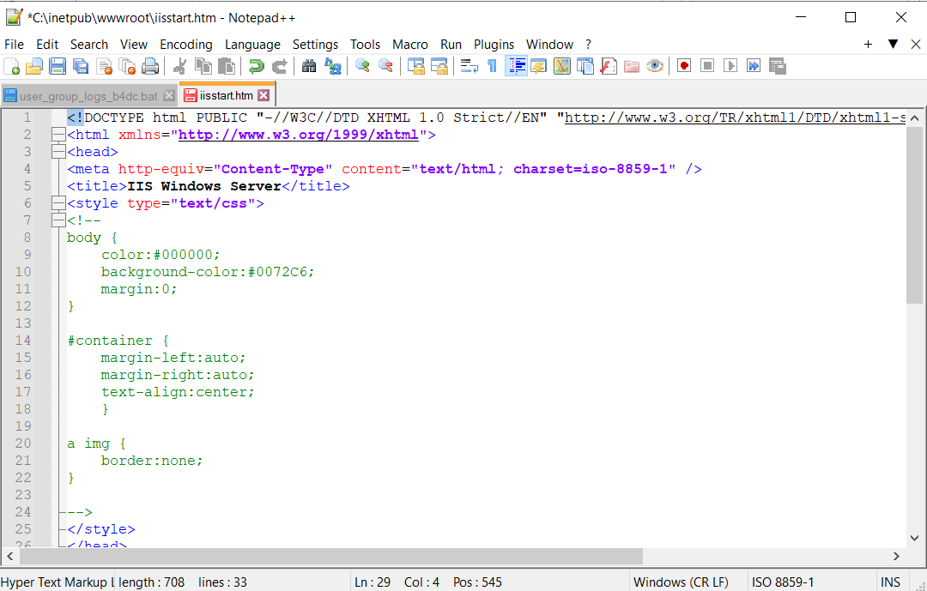
8. This will be completely replaced later but now add the p tags in the body, and include the following information.   
   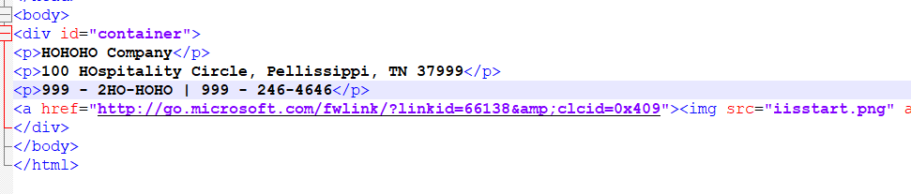
9. Save the file and visit 127.0.0.1 or localhost in the browser to verify your changes.   
   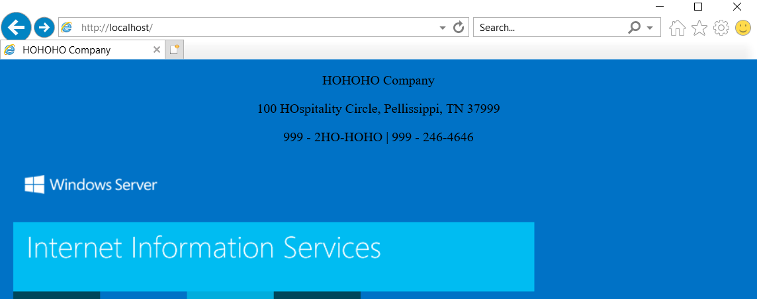

## Group Policy Settings

1. To achieve some of the more specific requirements we will need to configure some new group policies. Firstly we need to reconfigure our password policy as it has been overwritten by the default domain group policy. Open Group policy management by searching it in windows.   
   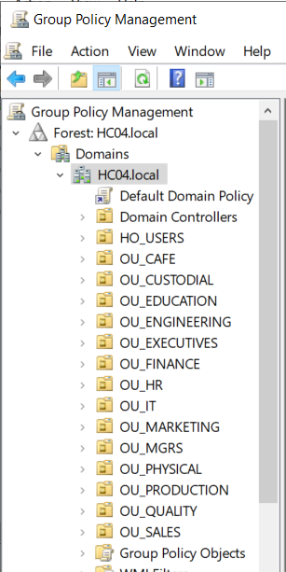
2. Right click on the domain and select create new GPO.  
   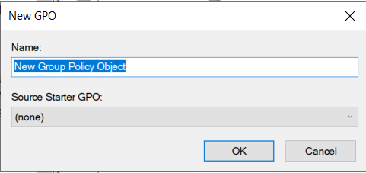
3. Name it appropriately. And create it.   
   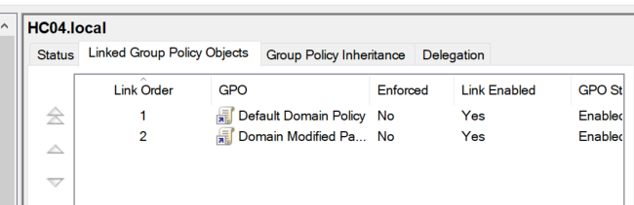
4. Right click and edit this policy.  
   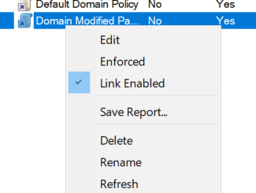
5. We need to drill down and find the password policy. Computer Configuration > Policies > Security Settings > Account Policies > Password Policy.   
   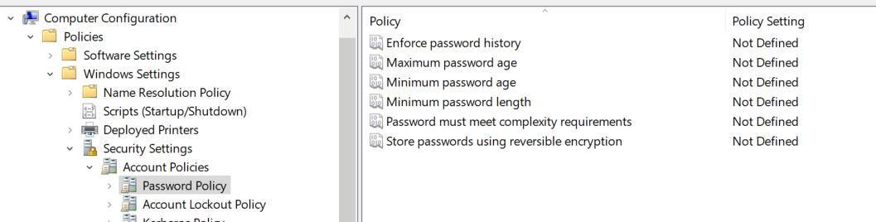
6. Double click the minimum password length option. Click the checkbox to define this policy and enter 0.   
   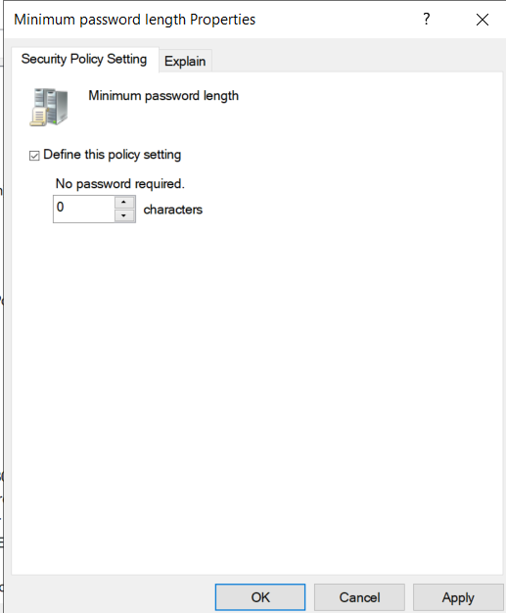
7. Do the same for password complexity requirements and disable them.  
   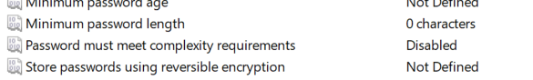
8. We will also configure the password history to ensure users cannot use the same password for 2 changes.   
   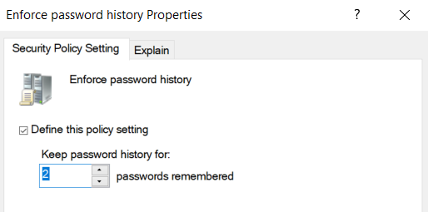
9. All domain users password will expire 120 after being set.   
   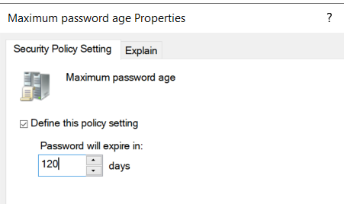
10. The above setting will configure a minimum password age, disable it.   
    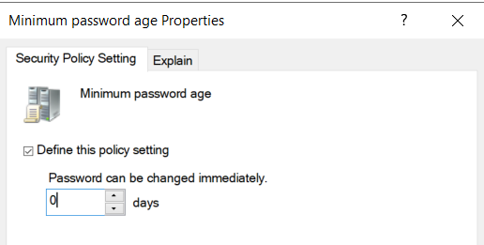
11. We will also configure the lockout policy. This is under the same Account policies tree. We will first configure the lockout threshold.   
    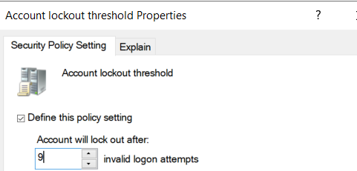
12. This will set the defaults for the duration and the reset. We will modify this to 1 minute for both.   
    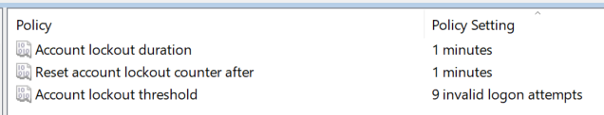
13. Close the policy editor. We will now enforce this policy by right clicking the policy and marking it as enforced.  
    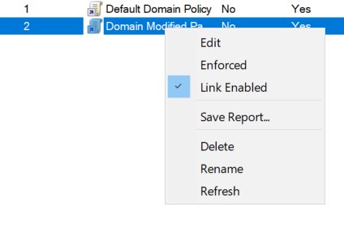
14. Open command prompt. Run “gpupdate /force” to apply this policy now.   
    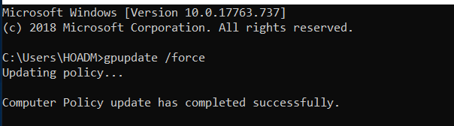

## Create Users and Groups

1. We will create one user and group via the GUI in active directory and the rest will be created via a PowerShell script.
2. First, we will create a user in active directory. Click the OU you would like to add a new user. Users in this case. Select new > user.  
   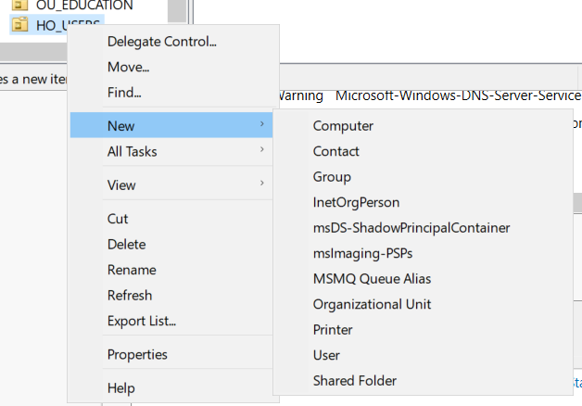
3. We will now fill out all of the user details according to company standard.   
   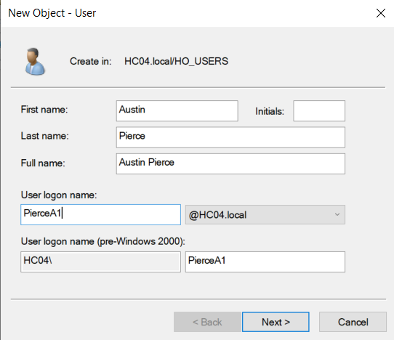
4. Next we will set the default password to pw. And ensure that users are not required to reset password at next login.   
   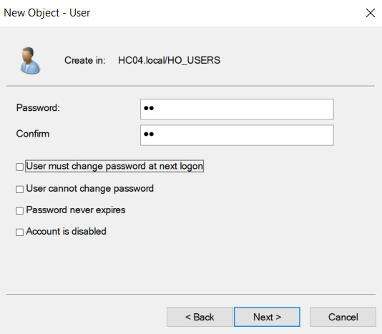
5. Verify user creation.   
   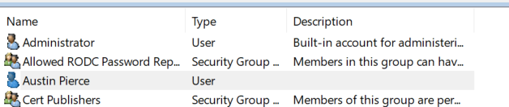
6. We can now set the finer details for this user, such as job title, right click the user and click properties.   
   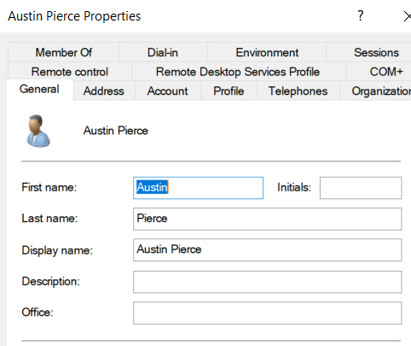
7. Find the organization tab and change the job title to the appropriate label. Lastly Apply your changes.   
   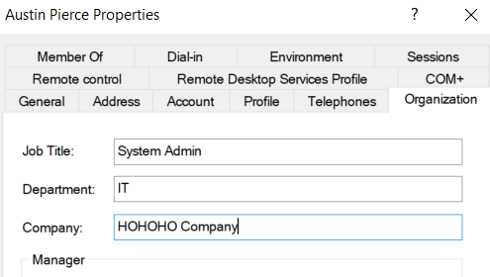
8. We will also need to create the appropriate departments groups as well. The groups will be created under the appropriate OU. See OU Structure section for OU Creation. For group creation, right click the OU and select new > group.   
   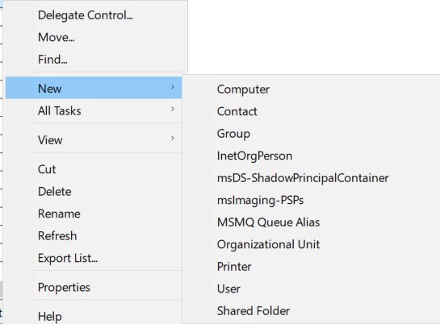
9. Fill in the appropriate information for each department  
   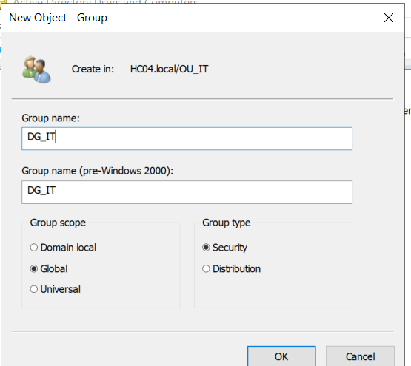
10. We will now add our user to this group. Access the properties of the newly created group and switch to the members tab.   
    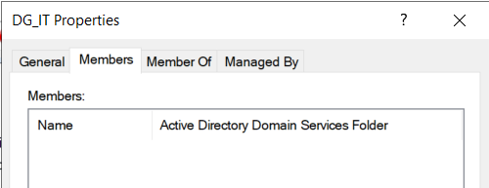
11. Select Add and search for the user we created.  
    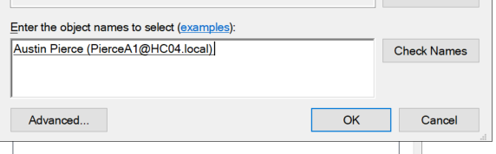
12. Apply changes and the user has been added.   
    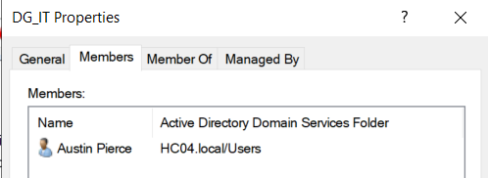
13. The script that creates all groups, users and adds users to the groups will be in the GitHub.  
    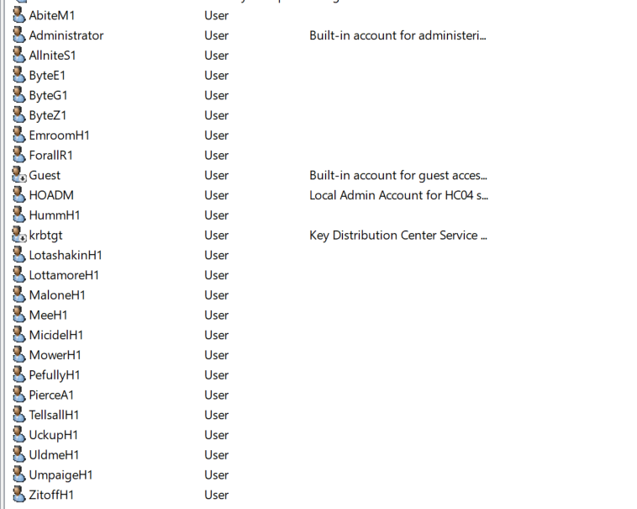
14. For each user we will need to add further information. Right click on each and modify their properties appropriately.   
    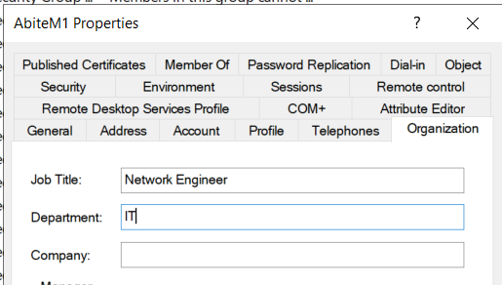
15. There are 3 scripts included. 2 powershell (group_creation and user_group_add) and 1 cmd script (user_create) that will handle the creation of users, groups and will automatically add the users to the appropriate groups. This are included in the GitHub.

## AD OU Structure

1. In server manager, click tools in the top right of the screen. Navigate to “Active Directory Users and Computers”.  
   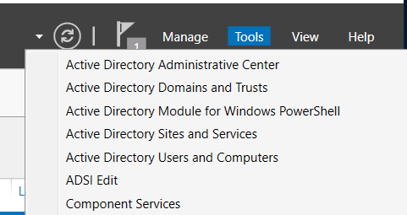
2. Break out the HC04.local domain tree and right click on the domain. Select new > Organizational unit.  
   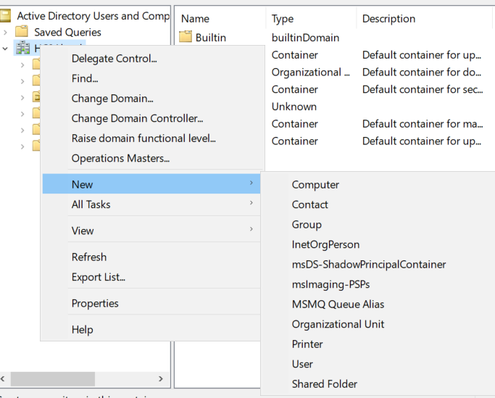
3. Each OU will be name OU_<DEPARTMENT>. For example OU_IT for the IT Department.  
   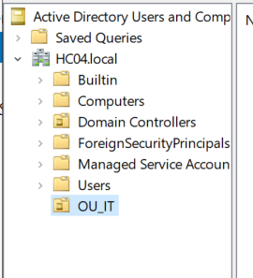
4. We will repeat this process for each department. The departments are as follows: IT, Mgrs, Executives, Finance, Sales, Production, Custodial, Quality, HR, Physical, Café, Marketing, Engineering, Education, and Advertising.  
   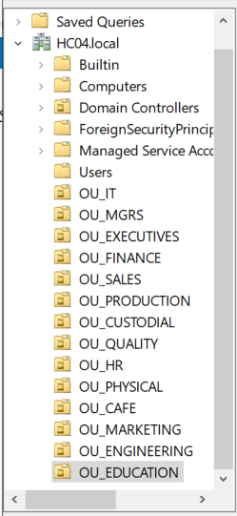
5. We also need to add the company’s information in Active Directory. Under Domain controller, right click and select properties.   
   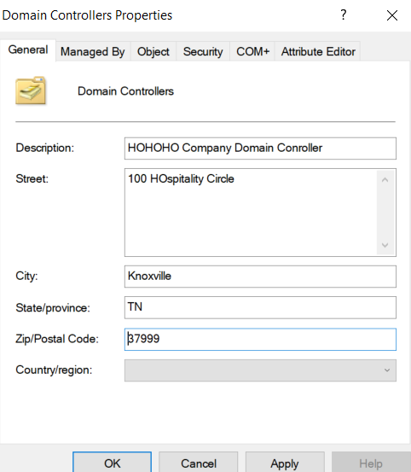

## Create Folders, Directories and Shares

1. In the C: volume create a folder named “DNLDS” (not shared).  
   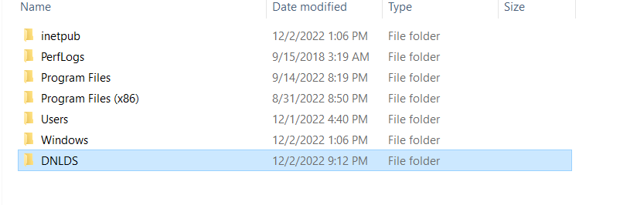
2. Create and share HOHOHOCO in the same directory. To share we will right click the newly created folder and go to properties. Click on the “Sharing” tab.  
   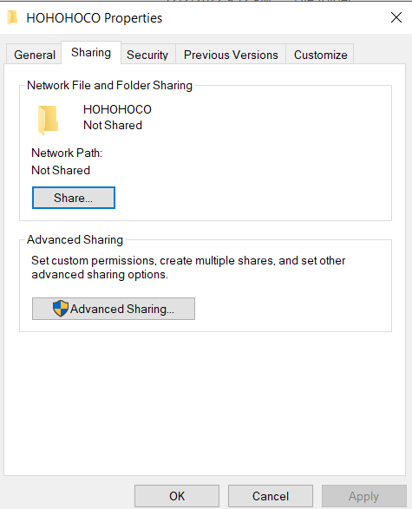
3. Select Advanced Sharing. Check the checkbox for “Share this folder”.  
   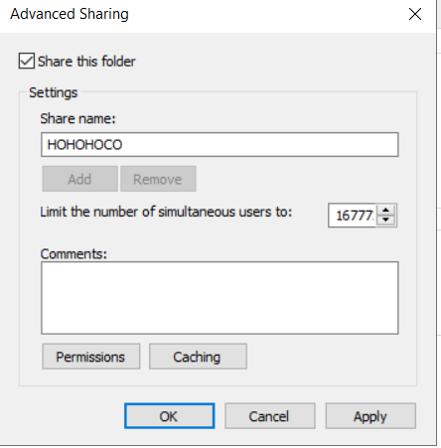
4. Change the share name to “HOCO-04”, Click on permissions. Remove everyone, and add authenticated users.  
   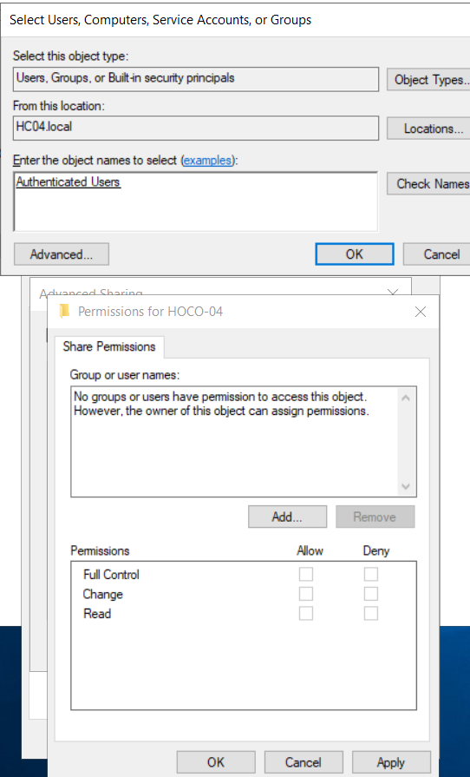
5. Give Authenticated users “Full Access” to the folder.   
   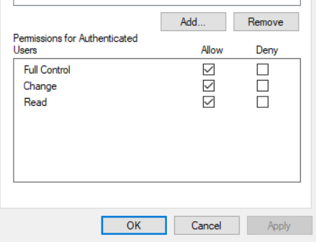
6. Apply Changes:  
   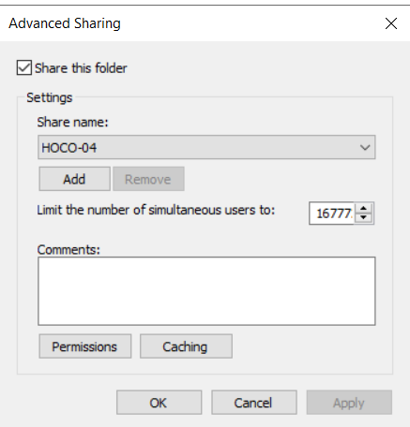
7. In the F: drive create a “Windows NT Compressed Folder” named “HOHO-COMPRESSED”. First create the new folder. Right-click and go to properties. Click “advanced”.  
   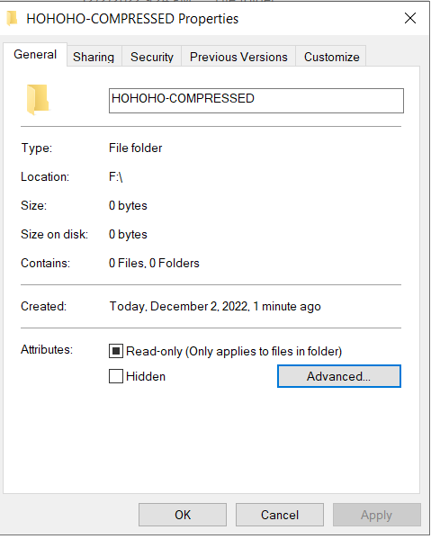
8. Check the box for “compress contents”  
   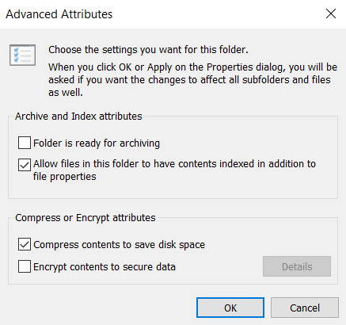
9. Next we will create an NTFS encrypted folder named “HOHO-Secure”. Create a new folder in the F: drive. Again go to properties > advanced. Check the box for “Encrypt contents to secure”  
   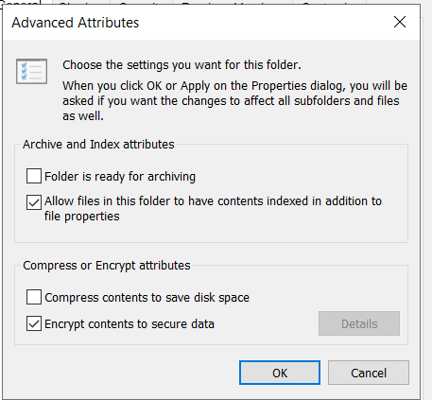
10. Review changes so far.   
    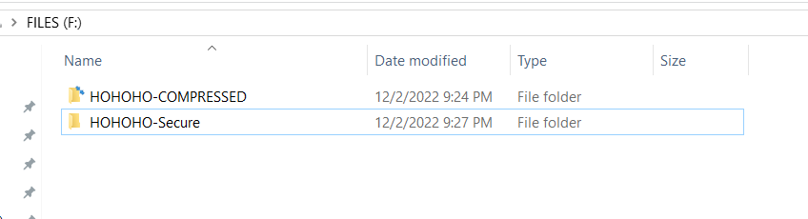
11. In the N: drive, create a folder named “working” shared as work. Repeat steps 2-4 stop at assigning access.  
    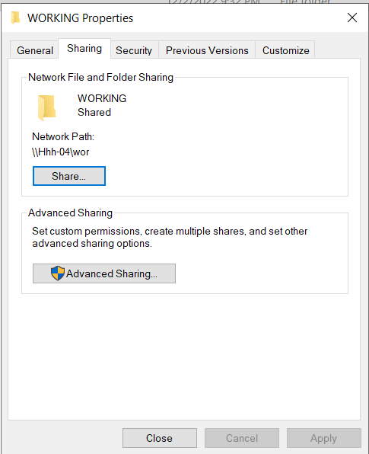
12. After the share has been configured, we need to modify the security for this share. Select the security tab, select advanced.   
    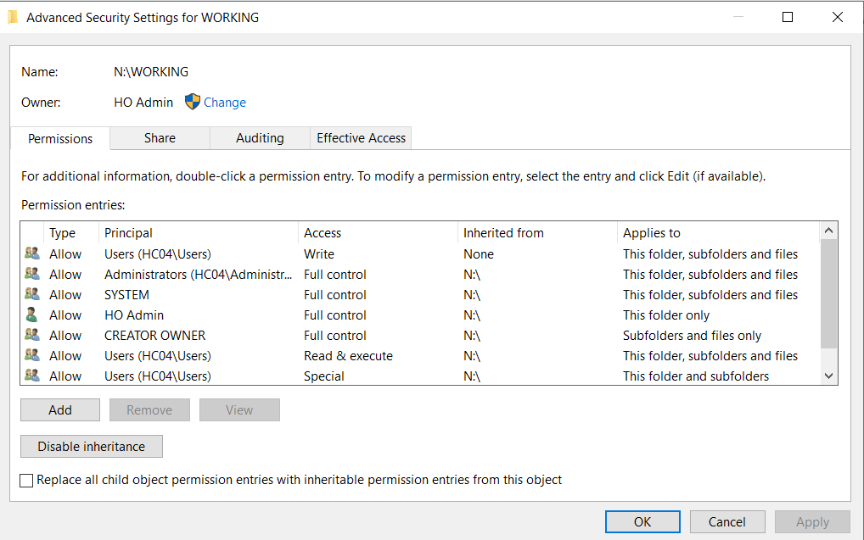
13. Select ADD, find authenticated users. Select advanced permissions, check the “allow” for create files/write data & folders. By default “Delete” is denied. When a user creates a file, they gain full access for that file therefore should be able to freely delete their files, while not being able to delete other users files. Apply changes.  
    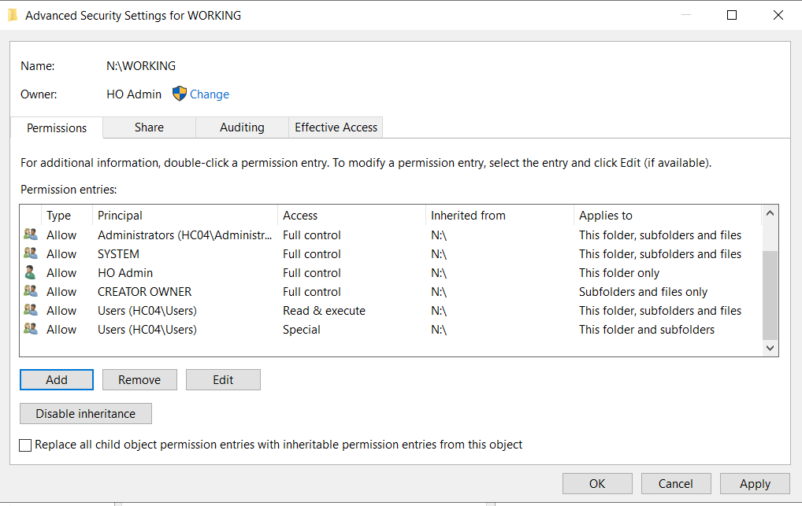
14. For the S: drive, we need to limit access to only managers, executives, and sys admins. This drive will also be logged for access. Right click the drive and go to properties > security.  
    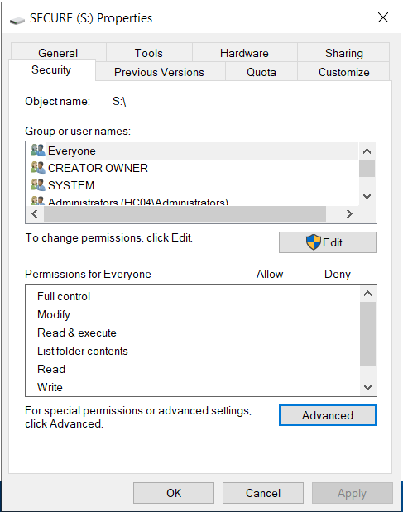
15. Edit access, remove everyone but “CREATOR OWNER, SYSTEM, ADMINISTRATORS”  
    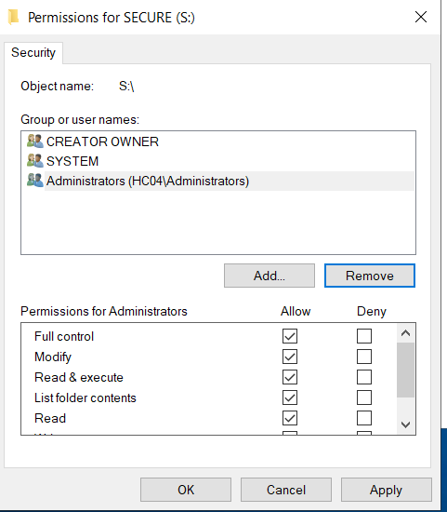
16. Add access for DG_EXECUTIVES, DG_MGRS-, Domain Admins.  
    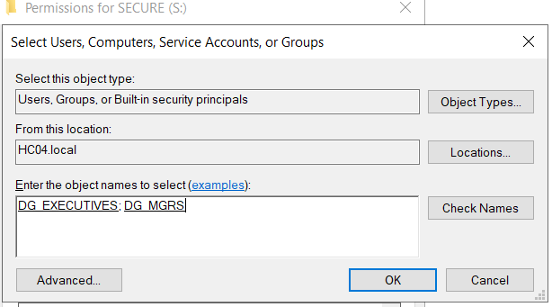
17. Add full control access for both new groups.  
    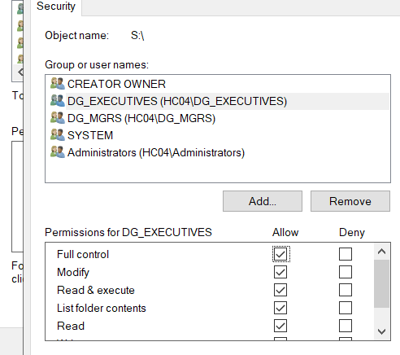
18. Go to advanced security settings select “Audting”. Select the principal, and select authenticated users. Change type to all.   
    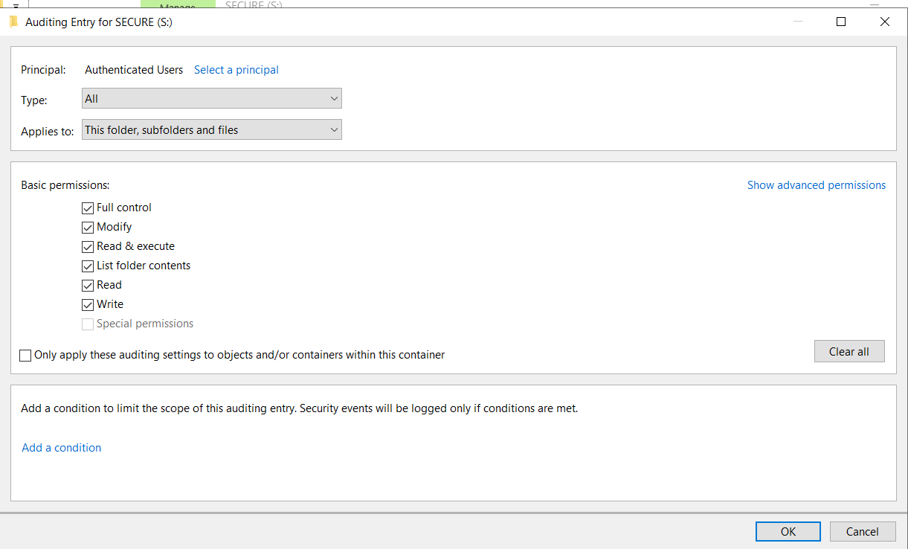
19. For the P: drive, right click properties and set change to the quota tab.   
    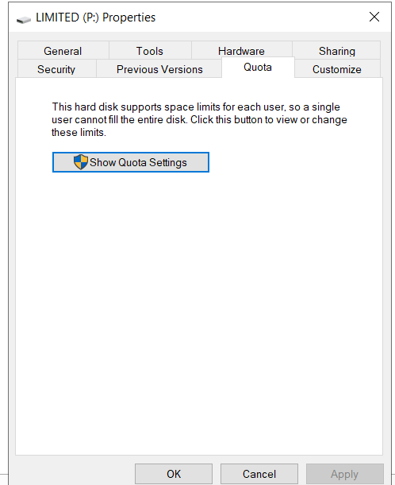
20. Enable quota management. Configure settings as the following:  
    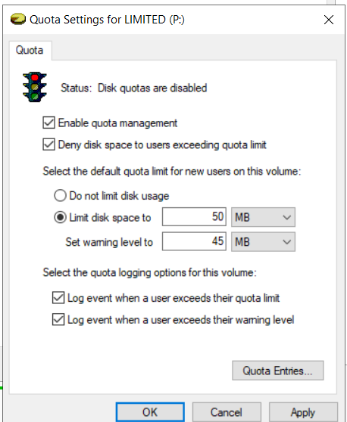
21. Use previous instructions to limit usage to only Managers, Executives, and sys admins.   
    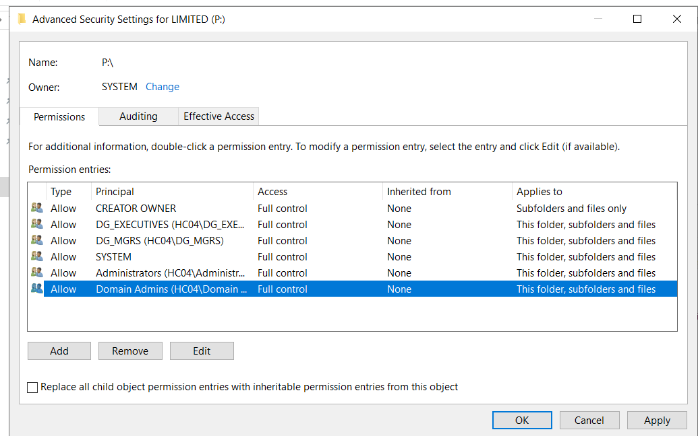
22. Add 3 shares in the F: Drive. First we will share F: as FILES.  
    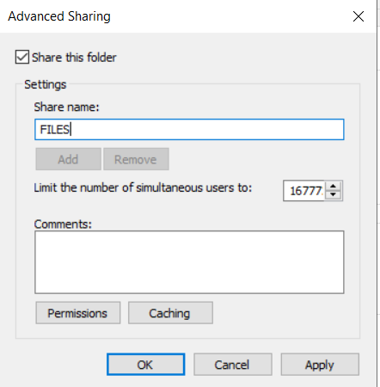
23. We will create 2 additional folders and share both of them as well. FZ and HO FILES. FZ will have a user limit of 50.  
    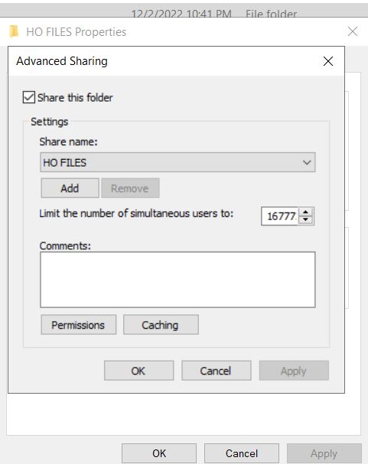 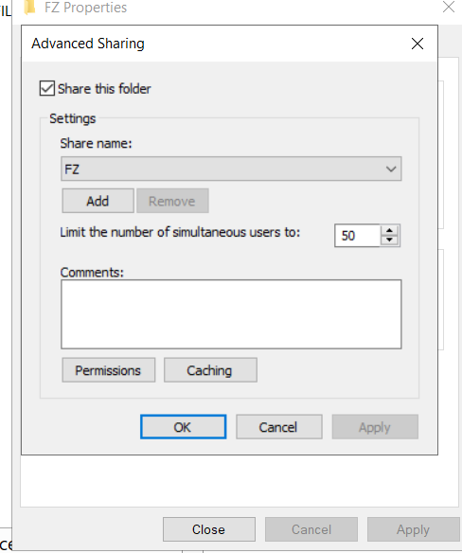

## Special User Permissions

1. Ho Humm is forced to change password at next login.   
   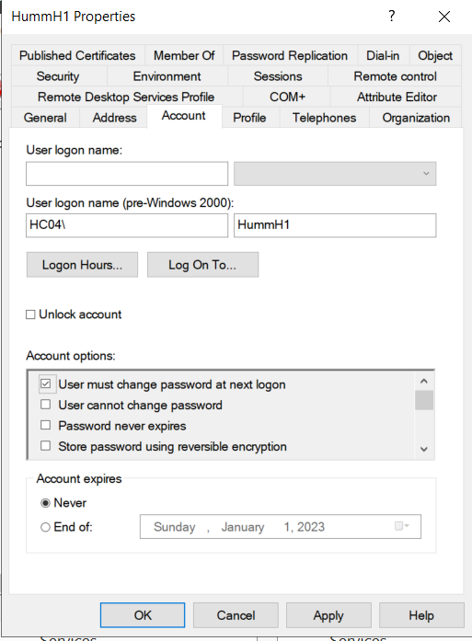
2. Ho Uckup and Ho Micidel cant change their password. 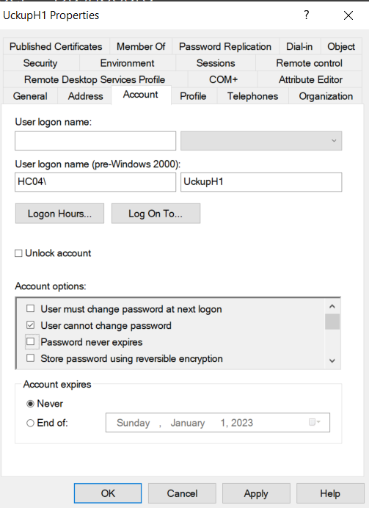 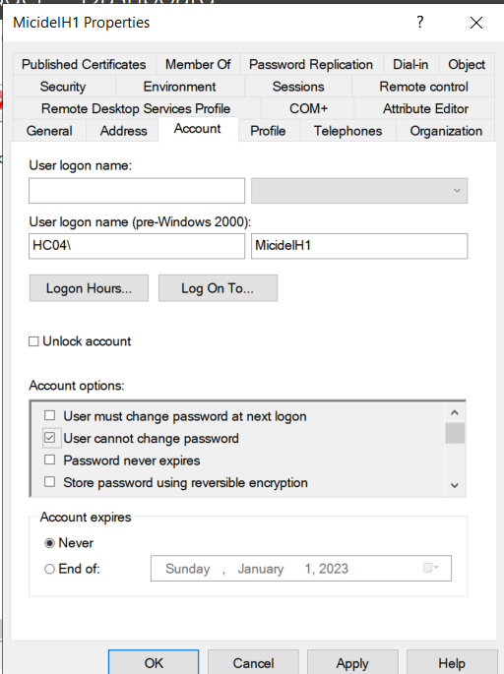
3. Ho Lottamore, Ho Umpaige, Ho Mee and need to be in the enterprise admin group.  
   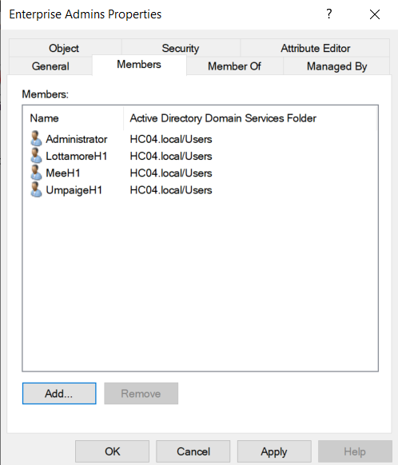
4. All IT members need to be Domain Admins:  
   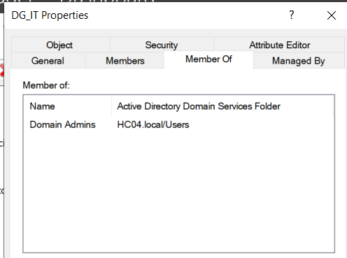
5. Ho Malone will perform system backups.  
   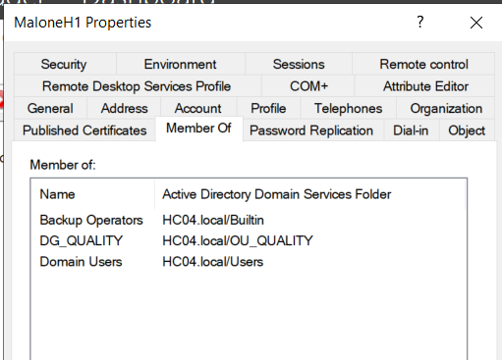
6. Ho Uldme will be a print operator.   
   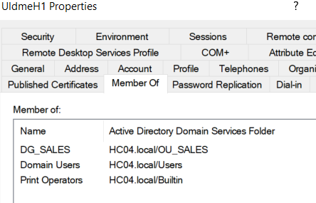

## Active Hours

1. IT can always log on for active hours. Management can log on anytime through the week but not on weekends. And normal users can log on, M-F 6AM – 9PM. Open each user’s account an modify their logon hours under “Account”.  
   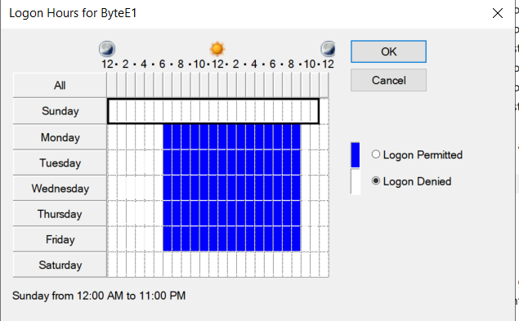

## Printers

1. We need to add 2 printers to our network and share them based on certain requirements. Open control panel and look for devices and printers.   
   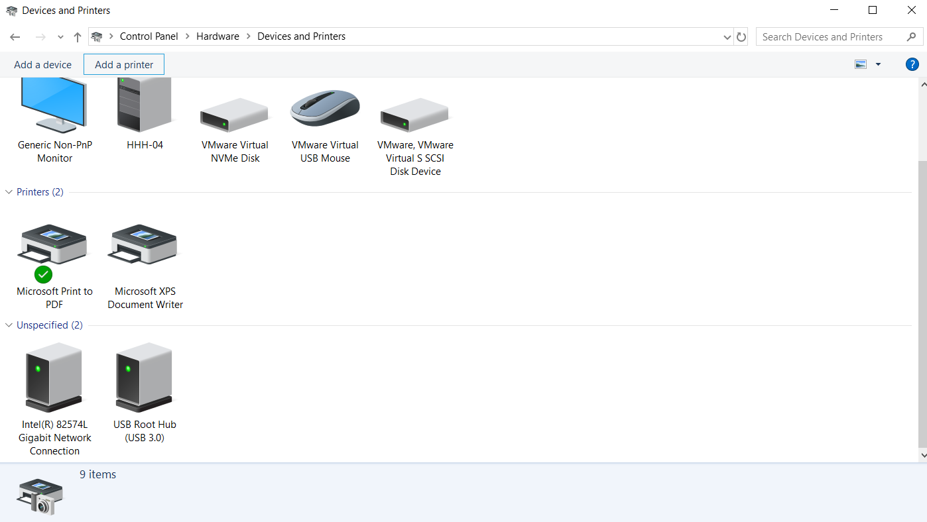
2. We are going to “Add a printer”. We will “Add a local or network printer as admin”.  
   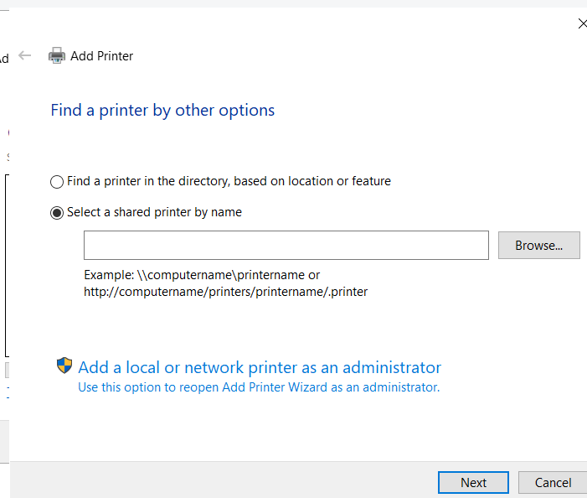
3. We will now “add a printer using tcp/ip address or hostname. Input the IP address of the printer – 192.168.50.251 in this case. Let windows attempt to find the printer.  
   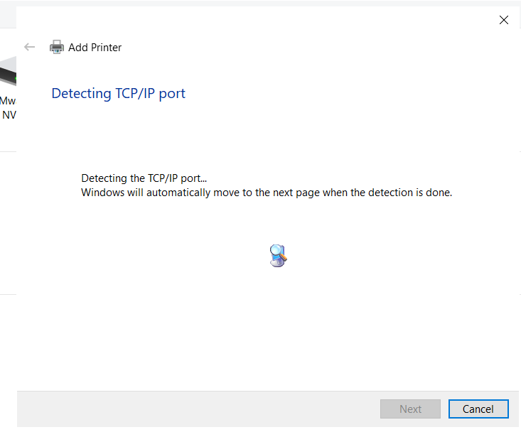
4. Leave the default values until you get to the “install print driver” page. Select, Windows update, to update list of print drivers.  
   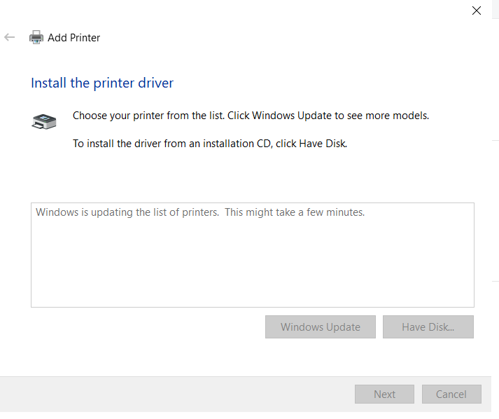
5. Select HP Laser Jet 600 M601 M602 M603 PCL6. And name appropriately.   
   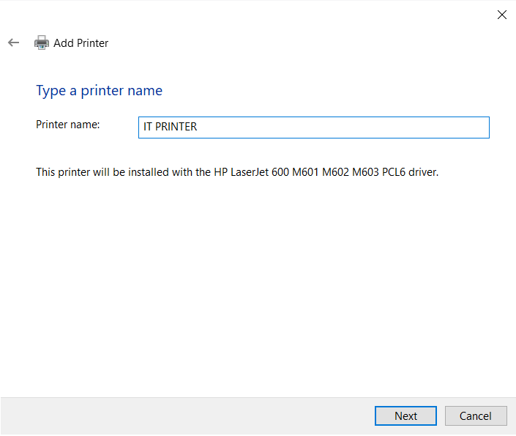
6. Next we need to share the printer as “IT ROCKS”  
   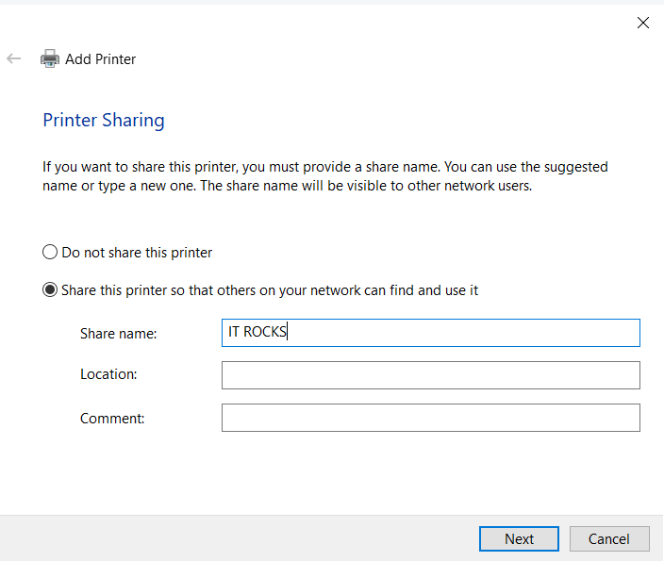
7. We will need to change the priority of the printer to the highest possible. Right the printer and go to printer properties. Set the priority to 99 under “Advanced”  
   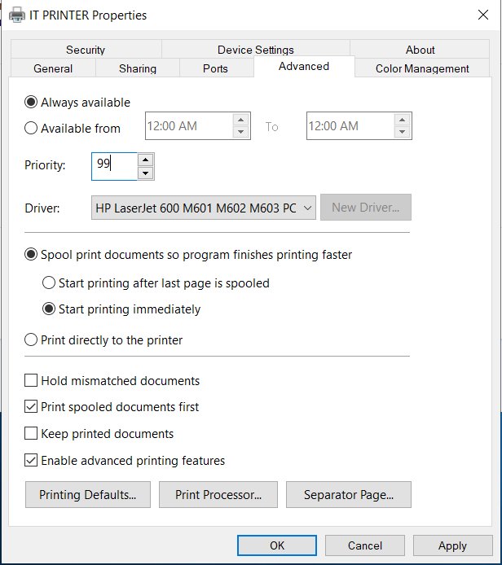
8. We need to restrict access to IT employees only. This can be done through the security tab.  
   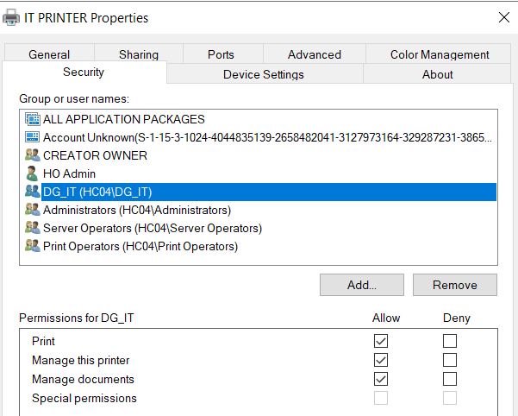
9. Repeat this process for another printer. The exception is this one is not shared and will require a separator page. We will also set this to the lowest priority. Stop after priority has been set and security has been configured for all users.   
   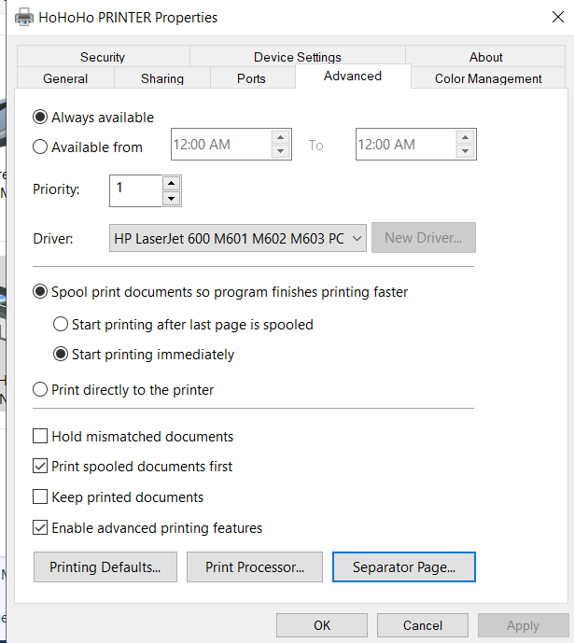
10. Select “Separator Page”. Browse to the bottom of the System32 folder and find the “sysprtj.sep” separator page. And Apply. We will need to modify this separator page. Navigate to your System32 folder. In the top right of the search bar type *.sep  
    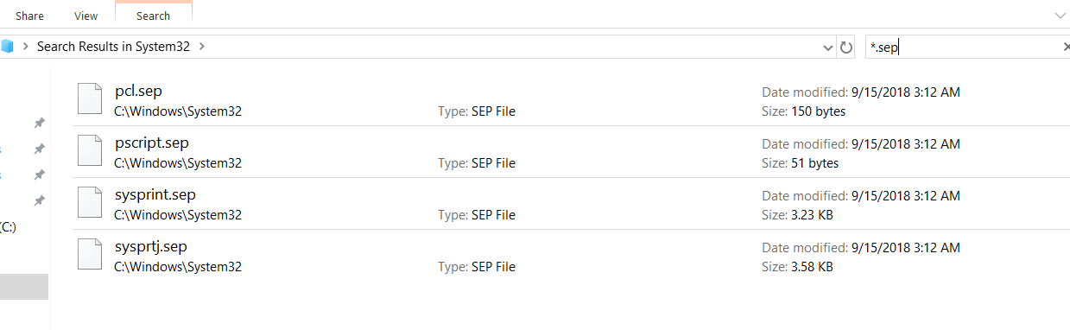
11. We are going to modify the sysprtj.sep separator page.  
    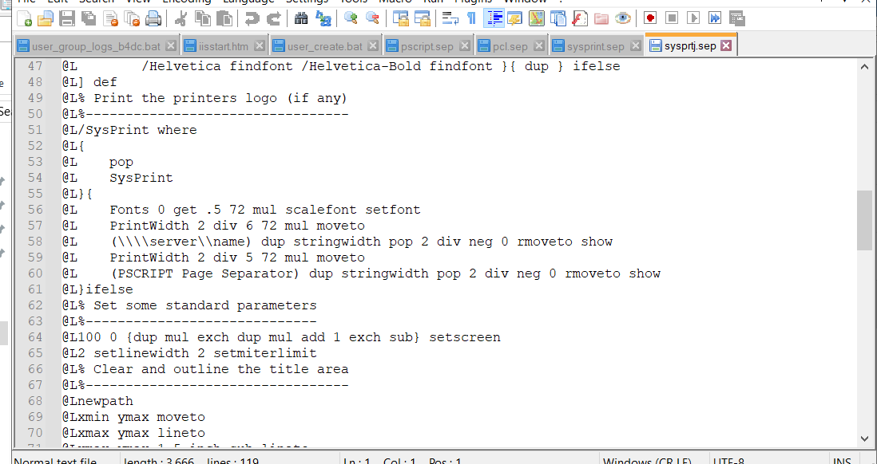
12. Configure custom settings, save and close.
13. Open event viewer, find “PrintService” and the operational log. Right click to enable.   
    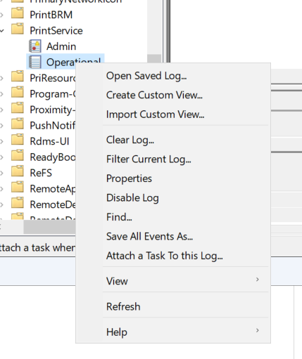

## Windows Client

1. Create a new windows 10 client machine. Stop after first boot.  
   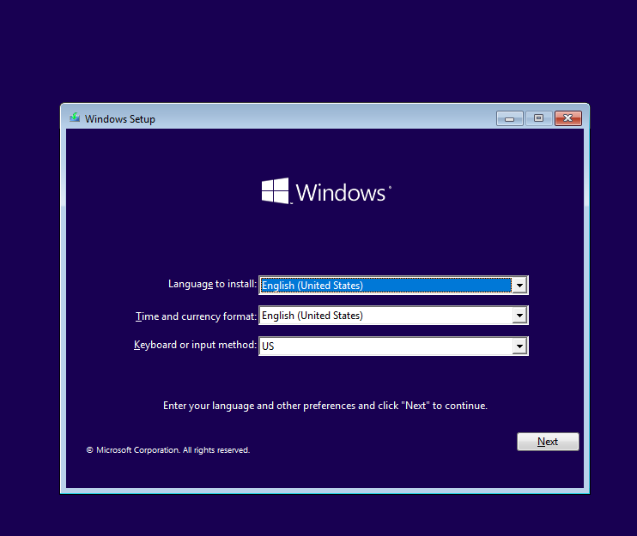
2. Next step is installation, start the installation and agree to terms. Custom Install.  
   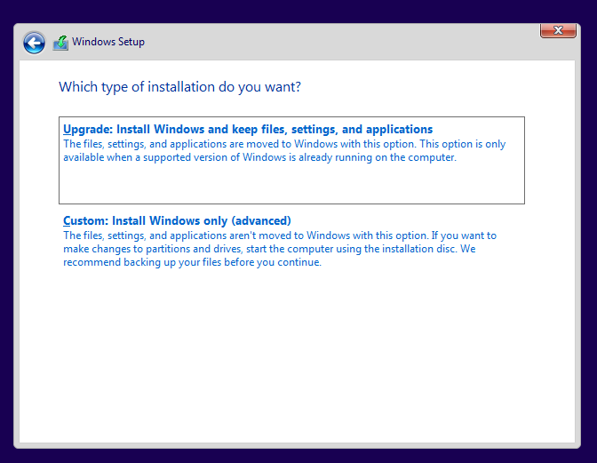
3. Create new partition for full drive size.  
   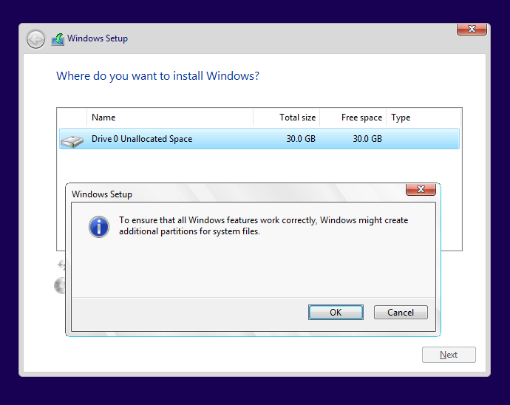
4. Allow windows to install.  
   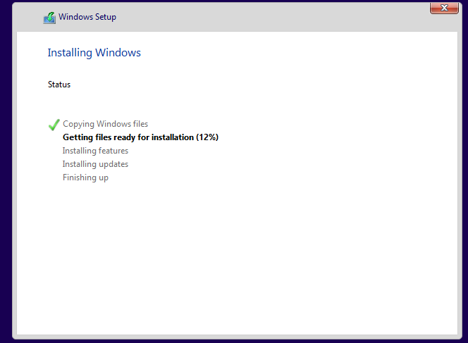
5. Complete the first time setup instructions. Stop after installation completes.  
   
6. We will set a test user for this client. After user creation we will need to set the time, and change the hostname for this computer. The time on this machine is already set properly but you can change it through the bottom right clock.  
   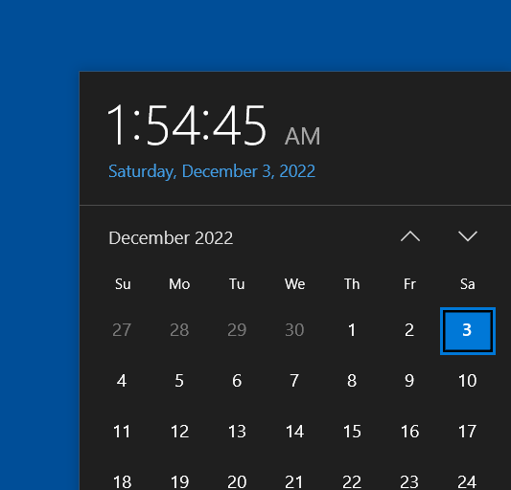
7. Rename this PC by navigating to the settings > about.  
   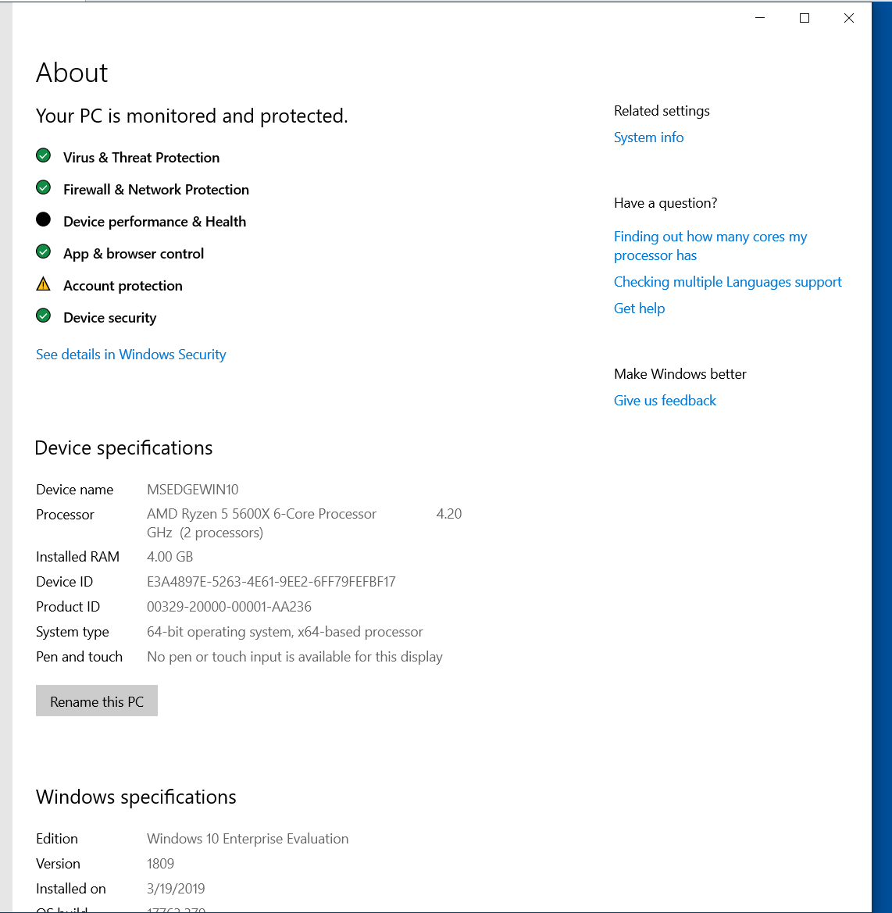
8. Select Rename this PC. This will require a reboot.  
   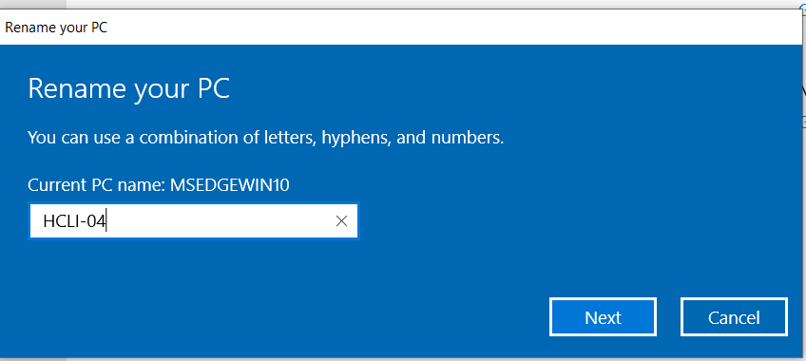
9. We will follow the same instructions from the server setup to configure the IP as static.  
   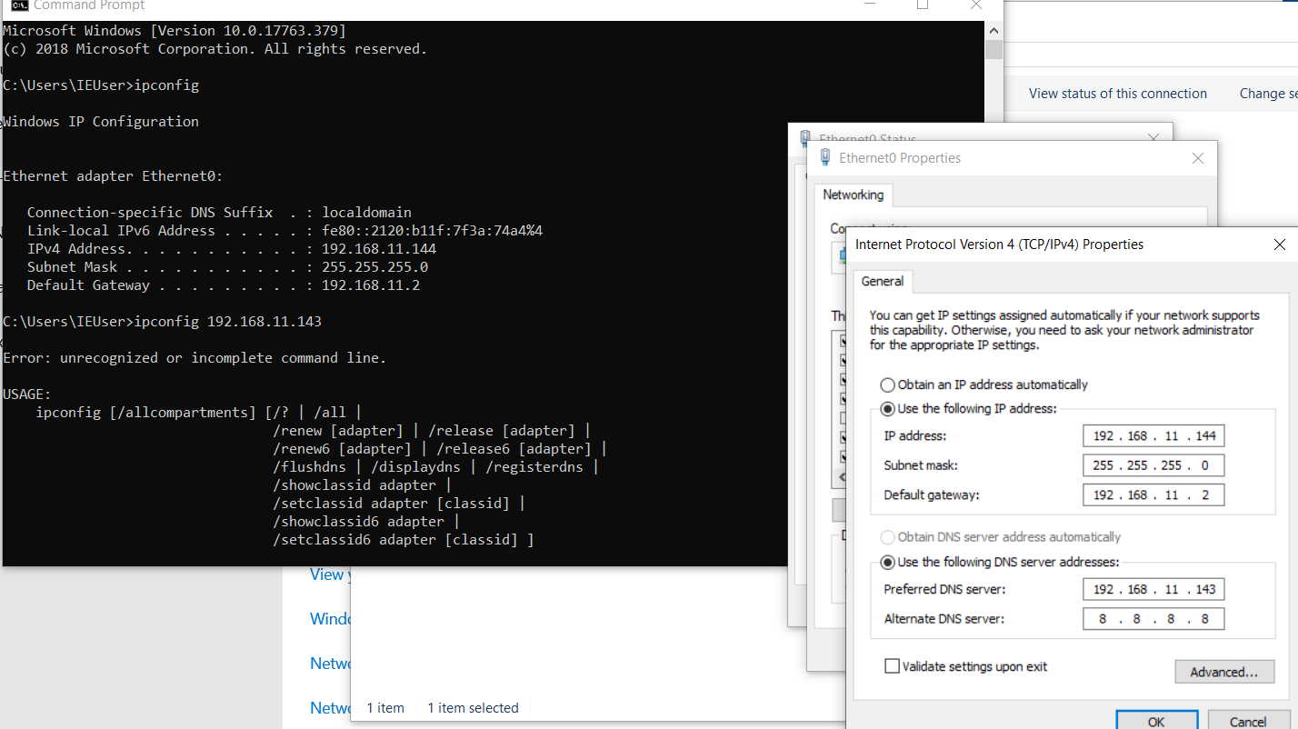
10. Lastly we will join the Domain. Search for Domain in windows search. Click connect, on the Access work or school. Select Join this device to a local Active directory domain.  
    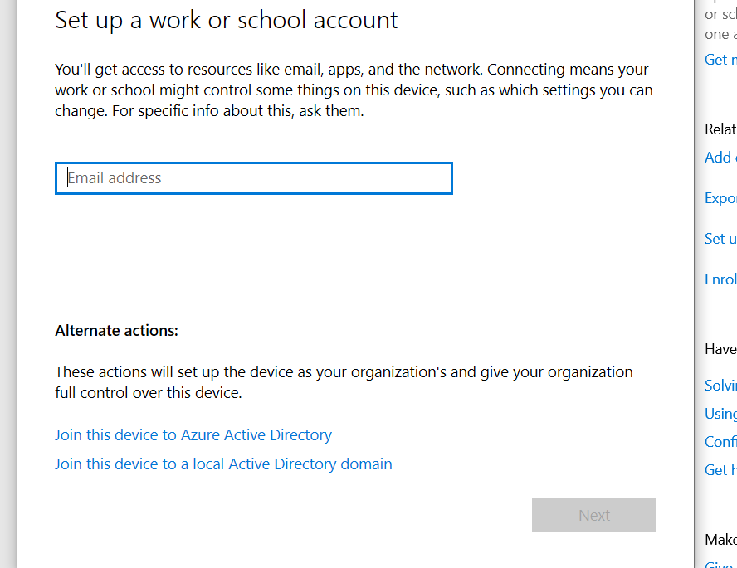
11. Enter domain admin credentials.  
    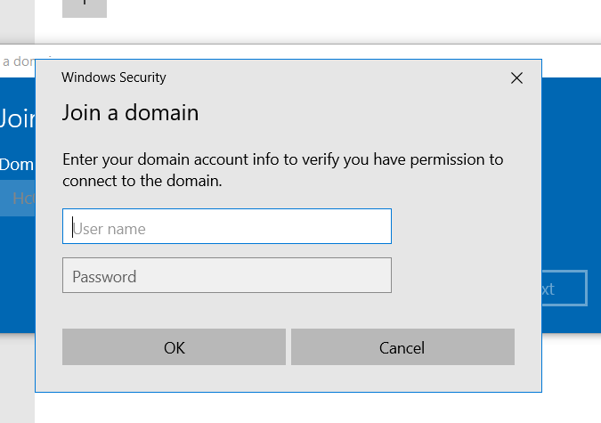
12. You can skip the adding a local profile portion, as we are now domain joined. Restart  
    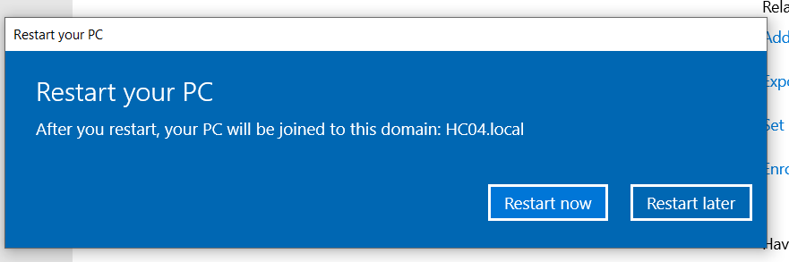
13. Verify on the server that you client is now connected.  
    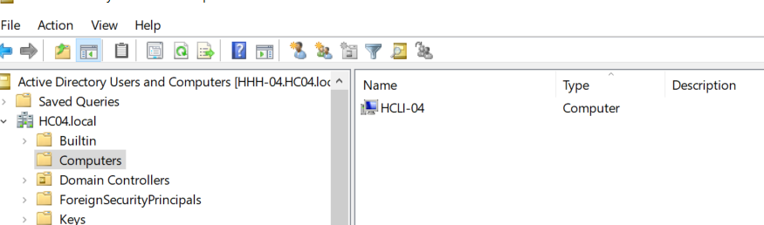

## IP TABLE:

|  |  |  |
| --- | --- | --- |
| Domain Controller 1 | HHH-04 | 192.168.11.143 |
| Client 1 | HCLI-04 | 192.168.11.144 |
| Printer 1 | IT PRINTER | 192.168.50.251 |
| Printer 2 | HOHOHO PRINTER | 192.168.50.251 |